Seismic Processing Workshop™

IO Utility™

V 2.1.18



The SPW System 4
About This Manual 6
Introduction to Tape Utility 7
Who Should Use Tape Utility 7
What You Need to Know to Operate Tape Utility 8
Window Layouts 8
Product Support 8
Tape Utility Main Menu 9
File Menu 10
Edit Menu 11
Control Menu 12
Window Menu 14
Help Menu 17
Tape Analysis 18
Tape Analysis Window 19
Note on Number Systems 22
Example: SEG-Y Format 24
Example: SEG-D Format 31
File Analysis 39
File Analysis Window 40
Note on Number Systems 43
SPW Reports 45
Example: SEG-Y Format 66
Example: SEG-D Format 74
Example: SEG-2 Format 82
Data Reformat 91
Reformat Window 92
Format Types 94
Example: Reformat from SEG-Y Format 95
Example: Reformat from SEG-D Format 100
Example: Reformat from SEG-2 Format 102
Outputting SPW files in SEG-Y format 104
Tape Database 110
Tape Image Copy 111
Copy Window 112
Input data types 116
Unformatted 117
SEG Y 118
SEG D 122
Creating Multiple Tape Copies 123
Input and Output from more than one tape 124
SPW File Merge 125
SPW File Merge Window 126
Tape Image Verify 129
Verify Window 130
Example: Verifying a SEGY Tape Image 133

Introduction

The SPW System

Welcome to the Seismic Processing Workshop (SPW) system. SPW is a suite of applications written by Parallel Geoscience Corporation for processing seismic and/or GPR data. The SPW system was originally written for the Macintosh computer platform and has been redesigned and rewritten using a cross platform framework. SPW is currently available for the Windows NT, Windows XP, Windows 2000, Linux, and Macintosh PowerPC operating systems. The SPW system is composed of the following applications – FlowChart, Executor, SeisViewer, Tape Utility, and Vector Calculator. Each of these applications is also available separately.

The FlowChart allows you to build processing flows and set the parameters for processing steps. A simple graphical user interface reduces the learning curve and accelerates your processing time. An interactive tutorial of the SPW FlowChart can be viewed at:

http://www.parallelgeo.com/products/SPWFlowChartIntroduction.htm

The Executor is a standalone seismic job execution engine. The Executor is multi-threaded to take full advantage of modern multiple CPU systems. The output of the FlowChart can be run by the Executor on the same system as the FlowChart or sent to a separate computer on a network. A single high-end system running the Executor can service multiple FlowChart client systems. This client-server design enables large jobs to be run on more powerful systems while user interactive tasks can occur on inexpensive desktop or laptop PC systems.

The SeisViewer is a seismic data display and montage application. Seismic data may be displayed from either SEG Y format disk files or from the SPW internal processing format. Drawing tools are included to allow you to annotate your seismic display. You can also import bitmap graphics files in BMP format to build a montage of other information with your seismic display. SeisViewer utilizes the standard Windows print drivers commonly delivered with printers for generating hardcopy output. You can also generate a BMP output file for use by other graphics applications. An interactive tutorial of the SPW SeisViewer can be viewed at:

http://www.parallelgeo.com/products/SPWSeisViewerIntroduction.htm

SPW Tape Utility is a data reformat, analysis, copy and verify program. As the name indicates, tape data handling is included in the application. All standard and many non-standard seismic data formats are handled in the data reformatting portion of the application. The copy and verify functions allow you to quickly and easily duplicate tapes for archive and/or distribution. The analysis functions allow you to view the contents of a tape in multiple human readable formats and enable you to decode the contents of the tape. An interactive tutorial of the SPW Tape Utility can be viewed at:

http://www.parallelgeo.com/products/SPWTapeUtilityIntroduction.htm

The SPW Vector Calculator is a trace analysis tool that operates like a scientific calculator, using Reverse Polish Notation. It can operate using scalar numbers as well as one-and two-dimensional vector numbers. You may use it for simple mathematical functions, or to analyze seismic trace data. You can create plots of seismic trace analyses, scale and control the annotation of these plots, as well as print them for reports. An interactive tutorial of the SPW Vector Calculator can be viewed at:

http://www.parallelgeo.com/products/SPWVectorCalculatorIntroduction.htm

The SPW system is designed to be user expandable. Parallel Geoscience will release the programming API interfaces for the FlowChart and the Executor to all SPW users in the near future. This will allow you to add your own customized processing algorithms and data formats to the SPW system.

About This Manual

This manual describes the main features of the SPW IO Utility. Examples will be presented for most of the commonly performed tasks. The features of this utility include the following:

- Tape Analysis
- File Analysis
- Data Reformat
- Tape Image Copy
- File Merge
- Tape Image Verify

Manual Developed
by
Parallel Geoscience Corporation
PO Box 5989
Incline Village, NV 89450

Tel: +1-541-412-7793
E-mail: support@parallelgeo.com

Web: http://www.parallelgeo.com,

SPW, Seismic Processing Workshop, SPW IO Utility, FlowChart, SPW Executor and SeisViewer are trademarks of Parallel Geoscience Corporation. All other products are trademarks of their respective companies.

This manual is proprietary information of Parallel Geoscience Corporation and is for the internal use only by licensed purchasers of SPW products.

© 2002 Parallel Geoscience Corporation

Introduction to IO Utility

Parallel Geoscience Corporation has been providing state-of-the-art seismic software solutions since 1988. Our Company philosophy is to offer quality products at affordable prices with exceptional support. We have satisfied users on every continent of the globe. This chapter introduces Parallel Geoscience Corporation’s IO Utility. Here you can find descriptions of the capabilities of the IO Utility application.

IO Utility is an interactive, window-oriented, menu driven application. It has six main features, which may be accessed upon opening the application. These features are 1) Tape Analysis, 2) File Analysis, 3) Data Reformat, 4) Tape Image Copy, 5) SPW File Merge and 6) Tape Image Verify.
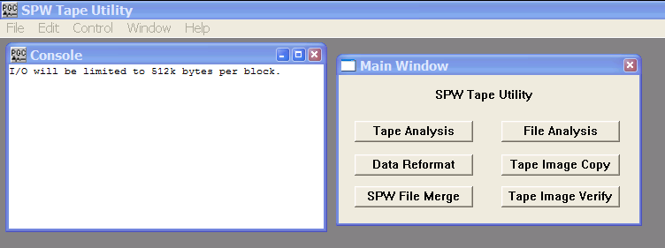

User Interface at Startup

Who Should Use IO Utility

Since IO Utility is a stand-alone application, it can be used in any environment where tape or disk data sets need to be accessed, analyzed, or reformatted. It is suitable for the field or office, allowing novice and well-experienced users to take advantage of its unique state-of-the-art capabilities.

Data management operations will find that routine chores run quickly, efficiently and inexpensively on this PC based software. Processing houses will find everything they need for copying, reformatting and analysis, leaving expensive workstations and mainframes free for more compute intensive tasks. Tape Utility is ideal for Field QC work. Multiple tape output, and special problem solving features are strong reasons for taking SPW IO Utility anywhere in the world.

What You Need to Know to Operate IO Utility

This manual assumes you have a basic awareness of the Windows environment, SEG digital tape standards, as well as SCSI tape drives and disk functions. If you have never used Windows before, and are unfamiliar with basic operations, have someone give you a personal demonstration or consult the owner’s manuals and tutorials. Consult the manufacturer’s documentation on the use of SCSI tape devices. The SEG standards may be obtained from:

Society of Exploration Geophysicists
P.O. Box 702740
Tulsa, Oklahoma
USA 74170-2740
1+918-497-5500

Many of the SEG technical standards are available as free downloads from:

http://seg.org/publications/tech-stand/

Window Layouts

All window layouts in IO Utility follow the Microsoft Windows convention. The name of the window appears at the top. If the standard default colors are used, the bar at the top is bright blue when the window is active and turns a faded blue when another window is selected. At the far right of this bar is the point-and-click X box, which allows you to close the window. Adjacent to this box are often two other boxes. One is for resizing. The other is to iconify the window to the bottom of the screen. Clicking on the icon makes the window reappear. Typically an OK or Cancel button is provided to allow you to exit the active window. By moving the cursor to the edge or corner of a window and using the click-and-drag technique you can resize the window. If you want to relocate the window to another part of the screen, click and drag the blue bar at the top of the window and position the window on the screen wherever you please.

Product Support

For solutions to questions about IO Utility, first look in this manual or consult the release notes accompanying every IO Utility software release. If you cannot find answers in your documentation, contact Parallel Geoscience Corporation via E-mail (support@parallelgeo.com, or phone (+1-541-412-7793). Please be ready to provide the following information:

- Your name.
- Your company name.
- The IO Utility version you are using.
- The operating system you are using.
- The type of hardware you are using.
- What you were doing when the problem occurred.
- The exact wording of any error messages which appeared on your screen.
- Any other pertinent data set information.

IO Utility Main Menu

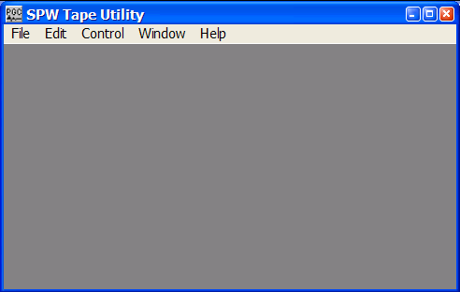
Several IO Utility commands are accessed through the main menu on the SPW IO Utility window. Each of these commands will be described in the following pages
The SPW IO Utility main menu.

File Menu
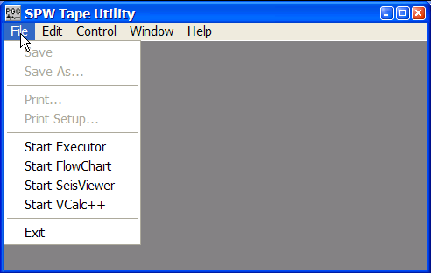

File Menu

Save - Not active.

Save as… - Not active.

Print - Not active.

Print Setup - Not active.

Start Executor - Launches the Executor.

Start FlowChart – Launches the FlowChart application.

Start SeisViewer – Launches the SeisViewer application.

Start VCalc ++ - Launches the Vector Calculator application.

Edit Menu

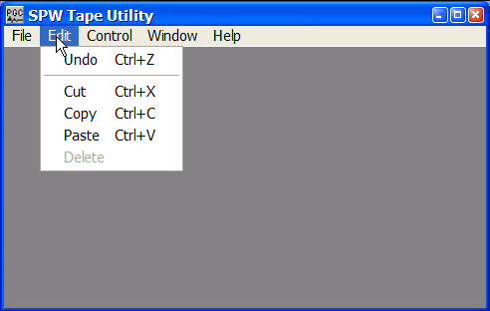
Edit Menu

Undo – Not active.

Cut – Not active.

Copy – Copies selected information in the dump window that may be transferred to a text editor using that applications paste command.

Paste – Not active.

Control Menu

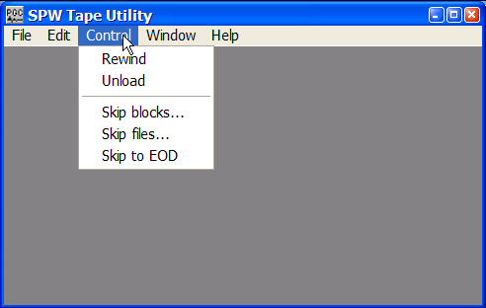
Control Menu

Rewind – Rewinds the tape in the selected SCSI tape drive to the start of tape.

Unload – Unloads the tape in the selected SCSI tape drive.

Skip blocks … – Skips the tape in the selected tape drive by the number of blocks entered in the Blocks to skip dialog. Positive entries skip the tape forward. Negative entries skip the tape backward.
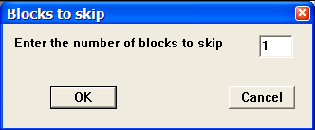
Blocks to skip dialog.

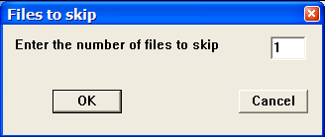
Skip files … – Skips the tape in the selected tape drive by the number of files entered in the Files to skip dialog. Positive entries skip the tape forward. Negative entries skip the tape backward.
Files to skip dialog.

Skip to EOD – Skips the tape in the selected tape drive to the end of data on tape.

Window Menu

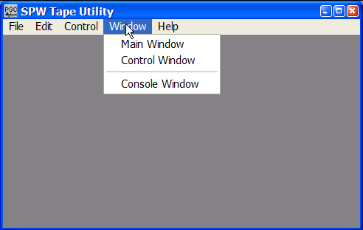
Window Menu

Main Window – Opens the SPW IO Utility Main Window dialog, from which all of the utilities are accessed.
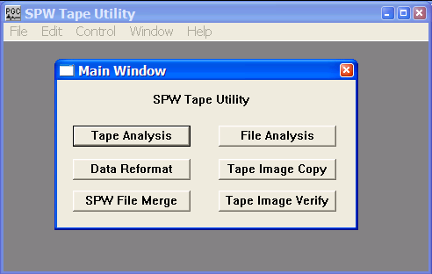
The Main Window dialog

Control Window – Opens the SPW IO Utility Control window.
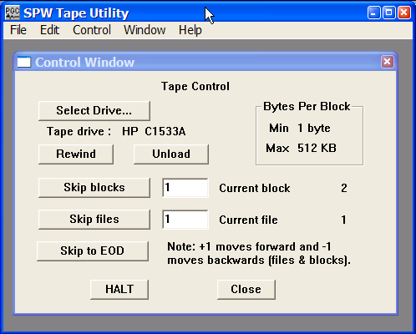
The Control Window dialog

Select Drive… – Select any attached SCSI tape drive.

Rewind – Rewinds the tape on the selected tape drive.

Unload – Rewinds and unloads the tape on the selected tape drive.

Skip blocks – Skips forward or backward by the number of blocks indicated in the adjacent parameter field. Positive values cause the tape to skip forward. Negative values cause the tape to skip backward.

Skip files – Skips forward or backward by the number of files indicated in the adjacent parameter field. Positive values cause the tape to skip forward. Negative values cause the tape to skip backward.

Skip to EOD – Skips forward to the end of data on tape.

Halt – Stop the current action on the selected tape drive.

Close – Close the Control Window.

Console Window – Opens the SPW IO Utility Console window.
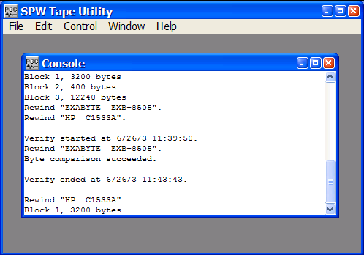

The Console dialog

Help Menu

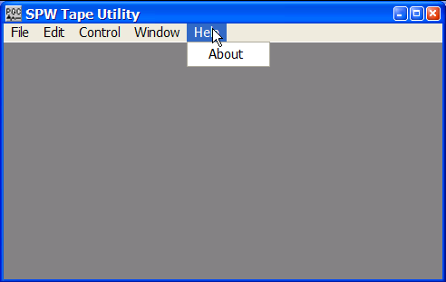
Help Menu

About – Opens a dialog that contains the SPW IO Utility version number.

Tape Analysis

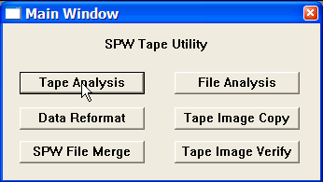
The Tape Analysis utility is designed for the efficient analysis of tape s whose content is unknown or problematic. To use the Tape Analysis utility, simply click on the Tape Analysis button in the Main Window and the Tape Analysis window will appear.
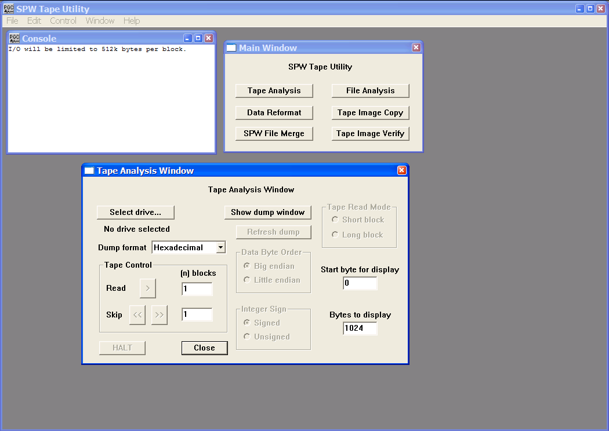
Main Window

Tape Analysis Window

The remainder of the chapter will: (1) discuss the various features of the Tape Analysis window; (2) explain the number systems that the Tape Analysis utility is capable of interpreting; and (3) provide examples of the analysis of actual SEG-Y, SEG-D, and SEG-2 data s to determine the parameters necessary to reformat those s to SPW format.

Tape Analysis Window
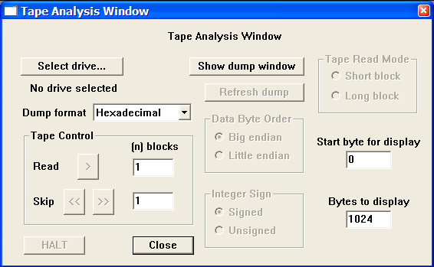
The Tape Analysis Window.

Parameter Dialog

Select drive… The Select drive button opens the Input Tape Select dialog, which allows you to select an external tape drive that contains a physical tape with data to be analyzed. Once a drive has been selected, the name of the drive will appear beneath the Select drive… button.
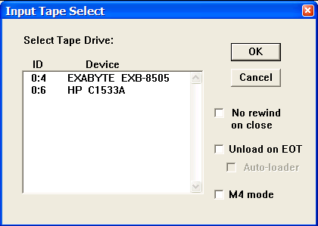
No rewind on close – The input tape will not be rewound at the end of the tape analysis session.

Unload on EOT – The tape automatically rewinds and unloads when the end of tape marker is found.

Auto-loader – Indicates that an auto-loader will be used to load multiple input tapes.

M4 mode – Check M4 mode if an M4 tape drive is selected.
Dump Format – A drop down menu is used to select the format in which the selected data will be dumped into the Tape dump window. Dump formats include Hexadecimal, ASCII, EBCDIC, Short Integer, Long Integer, IBM Float, and IEEE Float.

Show dump window - The Show dump window button is a toggle that allows the dump window to be displayed or hidden. When the Show dump window button is clicked, the Tape dump window appears and the button toggles to the Hide dump window button.

Refresh dump – The Refresh button is used to redump the same block of data after changing the dump format. This allows you to analyze the same block of data in several formats without returning repeatedly to the same starting block.

Tape Control – The Tape Control commands are used to control the position of the Tape Analysis utility and read data from the currently selected tape.

Read > Clicking the Read button cause the number of blocks entered in the Read parameter field to be dumped to the Tape dump window. The dump starts at the first byte of the current block.
Skip << >> Clicking the Skip button advance or reverses the current position of the Tape Analysis utility by the number of blocks entered in the Skip parameter field.

Start byte for display – Indicates the byte position in the current block from which the Tape Analysis utility will dump data for display.

Bytes to display - Indicates the maximum number of bytes that will be displayed in the Tape Dump Window from the blocks selected for a tape dump. This value may be greater than or less than the actually number of bytes contained in the blocks.

Data Byte Order

Big endian – If checked, the Tape Analysis utility will read integer values in big endian byte order. In big endian byte order the most significant byte of the integer value is stored in the first, or lowest data address.

Little endian - If checked, the Tape Analysis utility will read integer values in little endian byte order. In little endian byte order the least significant byte of the integer value is stored in the first, or lowest data address.

For example, the 4-byte integer representation of the decimal value 2049 (2¹¹ +1) is:

00000000 00000000 00001000 00000001

When written to as a sequence of 1-byte (8-bit) entries, the big- and little-endian representations are as follows:

Byte | Big-endian | Little-endian
0 | 00000000 | 00000001
1 | 00000000 | 00001000
2 | 00001000 | 00000000
3 | 00000001 | 00000000
Integer Sign

Signed – If checked, integer values will be read as signed, implying that when the value was written to tape a sign bit was coded.

Unsigned - If checked, integer values will be read as unsigned, implying that when the value was written to tape a sign bit was not coded.

For example, a signed Short Integer (2-bytes) will use 1 bit for a sign bit and 15 bits to store the sample value. Therefore, the possible range of data values is –2¹⁵ to 2¹⁵-1, or –32,768 to 32,767. An unsigned Short Integer (2-bytes) will use all 16 bits to store the sample value. Therefore, the possible range of data values is 0 to 2¹⁶-1, or 65,535.

Tape Read Mode - The tape read mode options are not applicable on Windows and Linux operating systems.

Short Block – To be used if the SCSI device reads in data blocks less than or equal to 64kb. This is the case with Mac OS X.

Long Block – To be used if the SCSI device reads in data blocks larger than 64kb. This is only an issue on the older Mac OS (pre OS X).

Note on Number Systems

The Tape Analysis utility is designed to dump binary information coded into a s byte structure in the following formats:

Hexadecimal
ASCII
EBCDIC
Short Integer
Long Integer
IBM Float
IEEE Float

The hexadecimal number system is used to compactly represent binary numbers. ASCII and EBCDIC are codes for representing English characters as numbers on a computer. Integer numbers are whole numbers that do not contain a fractional part. Floating-point numbers are real numbers that contain a fractional part. Floating-point numbers are always expressed as

Floating point number = (sign)*(fraction)*(base ^{exponent-bias}).

Each of these variable types will be discussed briefly.

Hexadecimal – The hexadecimal number system is a base 16 system that uses the values 0-9 and A-F to represent decimal numbers. Hexadecimal values are often display with the suffix “H”, such a 33a5H for the value 33a5. The following chart displays the conversion between decimal, binary, and hexadecimal.

Decimal | Binary | Hexadecimal
0 | 0000 | 00H
1 | 0001 | 01H
2 | 0010 | 02H
3 | 0011 | 03H
4 | 0100 | 04H
5 | 0101 | 05H
6 | 0110 | 06H
7 | 0111 | 07H
8 | 1000 | 08H
9 | 1001 | 09H
10 | 1010 | 0AH
11 | 1011 | 0BH
12 | 1100 | 0CH
13 | 1101 | 0DH
14 | 1110 | 0EH
15 | 1111 | 0FH
16 | 1 0000 | 10H
Decimal-binary-hexadecimal conversion chart.

ASCII – ASCII is shorthand for American Standard Code for Information Interchange. The ASCII code was designed to represent English characters as numbers on a computer. In modern usage, ASCII is a byword for raw, text-only s.

EBCDIC – EBCDIC is shorthand for Extended Binary Coded Decimal Interchange Code. The EBCDIC code was designed by IBM to represent English characters as numbers on a computer. The EBCDIC code is used to store information in the SEG Y reel header.

Short Integers – A two-byte integer value that may be signed or unsigned. If signed, 1 bit is allocated for a sign bit and 15 bits are allocated to store the sample value. Therefore, the possible range of data values for a signed Short Integer is –2¹⁵ to 2¹⁵-1, or –32,768 to 32,767. If unsigned, all 16 bits are allocated to store the sample value. Therefore, the possible range of data values for an unsigned Short Integer is 0 to 2¹⁶-1, or 65,535.

Long Integers – A four-byte integer value that may be signed or unsigned. If signed, 1 bit is allocated for a sign bit and 31 bits are allocated to store the sample value. Therefore, the possible range of data values for a signed Long Integer is –2³¹ to 2³¹-1, or –2,147,483,648 to 2,147,483,647. If unsigned, all 32 bits are allocated to store the sample value. Therefore, the possible range of data values for an unsigned Long Integer is 0 to 2³²-1, or 4,294,967,296.

IBM Float – A floating point format in which contains 1 sign bit, 7 bits for the exponent, and 24 bits for the fraction.

IEEE Float – A floating point format in which contains 1 sign bit, 8 bits for the exponent, and 23 bits for the fraction.

Example: SEG-Y Format

The SEG-Y format is a demultiplexed seismic data format that consists of a 3600-byte reel identification header followed by trace data blocks (fig.1). The reel identification header consists of a 3200-byte EBCDIC (Extended Binary Coded Decimal Interchange Code) text file header and a 400-byte binary file header. Each of these two blocks contains information specific to the seismic data in the Tape File. The trace data block consists of a 240-byte binary coded trace identification header followed by the trace data samples. There is one trace identification header per trace. For more information concerning the SEG-Y Format standard, consult the SEG digital tape standards at

http://seg.org/publications/tech-stand/

To analyze a SEGY tape file, use the Select drive… button in the Tape Analysis window to open the Input Tape Select dialog. The Input Tape Select dialog is used to select an external tape drive that contains a physical tape with SEG-Y data to be analyzed. Once the desired tape drive has been selected, click on the OK button in the upper right corner of the Input Tape Select dialog. The Tape Analysis window will display the name of this tape drive directly beneath the Select drive… button.

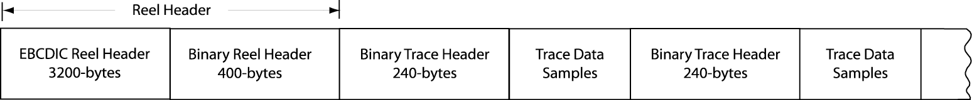

Figure 1. Schematic representation of a SEG-Y file.

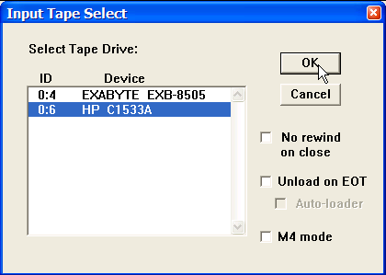
Input Tape Select Dialog
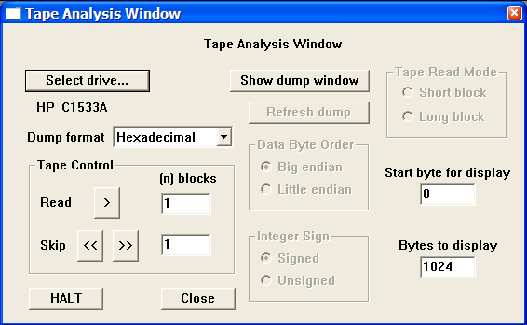
Tape drive containing a SEG-Y tape file has been selected for analysis.

A great deal of information can be extracted from a properly written SEG-Y reel header. As stated above, the reel header consists of a 3200-byte EBCDIC text header and a 400-byte binary header. The SEG-Y EBCDIC reel header contains 40 lines of comment cards, at 80-bytes per line. These comment cards are used to describe the contents of the SEG-Y. To read the EBCDIC header, set the dump format to EBCDIC using the drop down menu, the Start byte for display to <0>, the number of Bytes to display to <3200>, and instruct the Tape Analysis utility to read the first block of data by entering <1> in the parameter field to the right of the Read button in the Tape Control submenu.

Preparing to read a SEG-Y EBCDIC reel header.
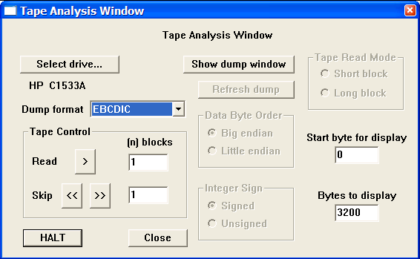

To dump the 3200-byte EBCDIC header to the File Dump Window, click on the READ > button in the Tape Control submenu. The dump window will appear with the contents of the EBCDIC header. In this case, the EBCDIC header was left blank.

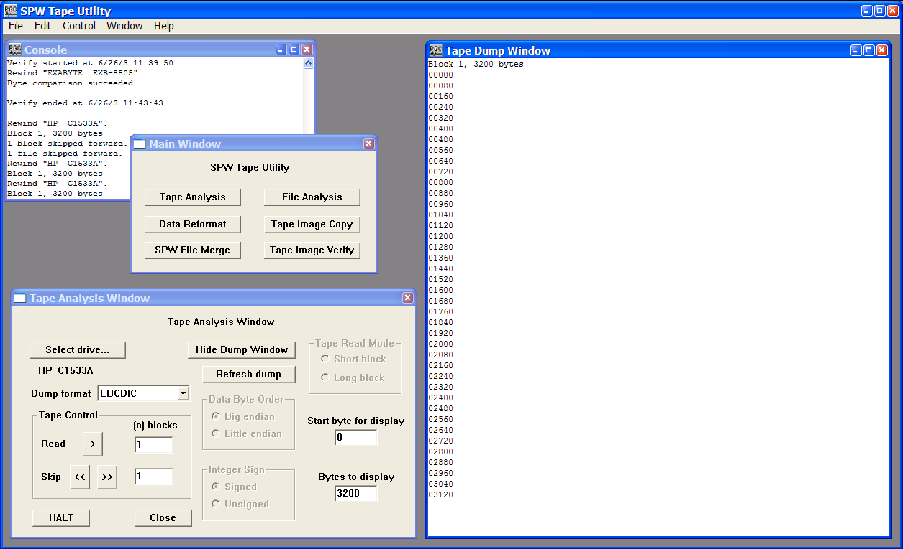
The EBCDIC text header displayed in the Tape Dump Window. This particular tape file was created with a blank EBCDIC text header.

After dumping the EBCDIC text header to the Tape Dump Window, the Tape Analysis utility is positioned at byte 3200 (start of block 2) of the selected SEG-Y tape file, which is the correct position to read the 400-byte binary reel header. To read the binary reel header, set the dump format to Short Integer, the Data Byte Order to Big Endian (or as appropriate), the Integer Sign to Unsigned, and instruct the Tape Analysis utility to read 1 block of data. Click on the READ > button in the Tape Control submenu to dump the binary reel header.

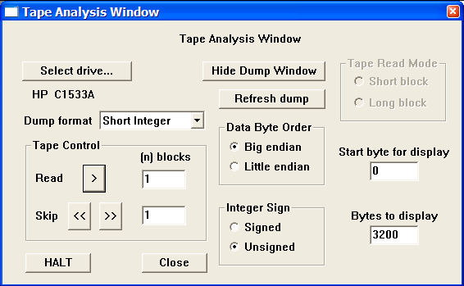
Preparing to read a SEG-Y binary reel header.

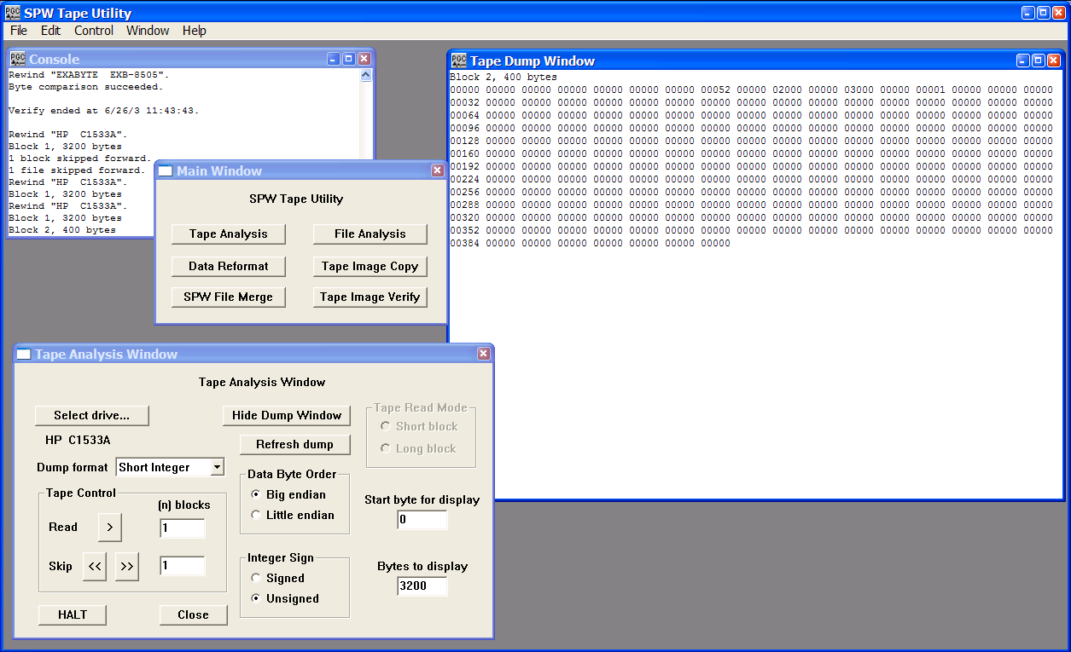
The Binary reel header displayed in the Tape Dump Window.

The first 60-bytes of the SEG-Y binary reel header are assigned values that are described in the SEG-Y standard. The remaining 340-bytes are left unassigned and may contain any information that the processor deems necessary. The binary reel header displayed in the Tape Dump window in the figure above contains mandatory information regarding the seismic file: (1) bytes 13-14 (bytes 3213-3214 in the file) indicate the number of data traces per record, in this case 52; (2) bytes 17-18 (bytes 3217-3218 in the file) indicate the sample rate in microseconds, in this case 2000; (3) bytes 21-22 (bytes 3221-3222 in the file) indicate the number of samples per data trace, in this case 3000; and (4) bytes 25-26 (bytes 3225-3226 in the file) indicate the data sample format code, in this case IBM floating point (1 = 4-byte IBM floating point).

After dumping the binary reel header to the Tape Dump Window, the Tape Analysis utility is positioned at byte 3600 (start of block 3) of the selected SEG-Y tape file, which is the correct position to read the 240-byte binary trace header corresponding to the first trace in the file. To read the first binary trace header, set the dump format to Short Integer, the Data Byte Order to Big Endian (or as appropriate), the Integer Sign to Signed, and instruct the Tape Analysis utility to read 1 block and display 240-bytes. The third block of data contains both the binary trace header and the corresponding data samples. Therefore, if you choose to display more than 240-bytes, you will see IBM floating point values interpreted as short integers. These values will appear to be meaningless. Click on the READ > button in the Tape Control submenu to dump the binary trace header.

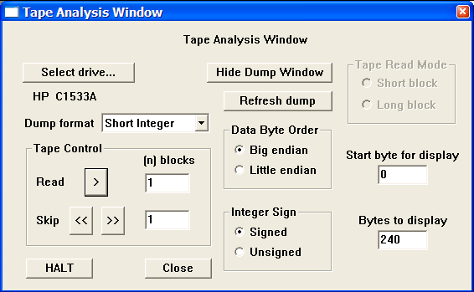
Preparing to read a SEG-Y binary trace header.

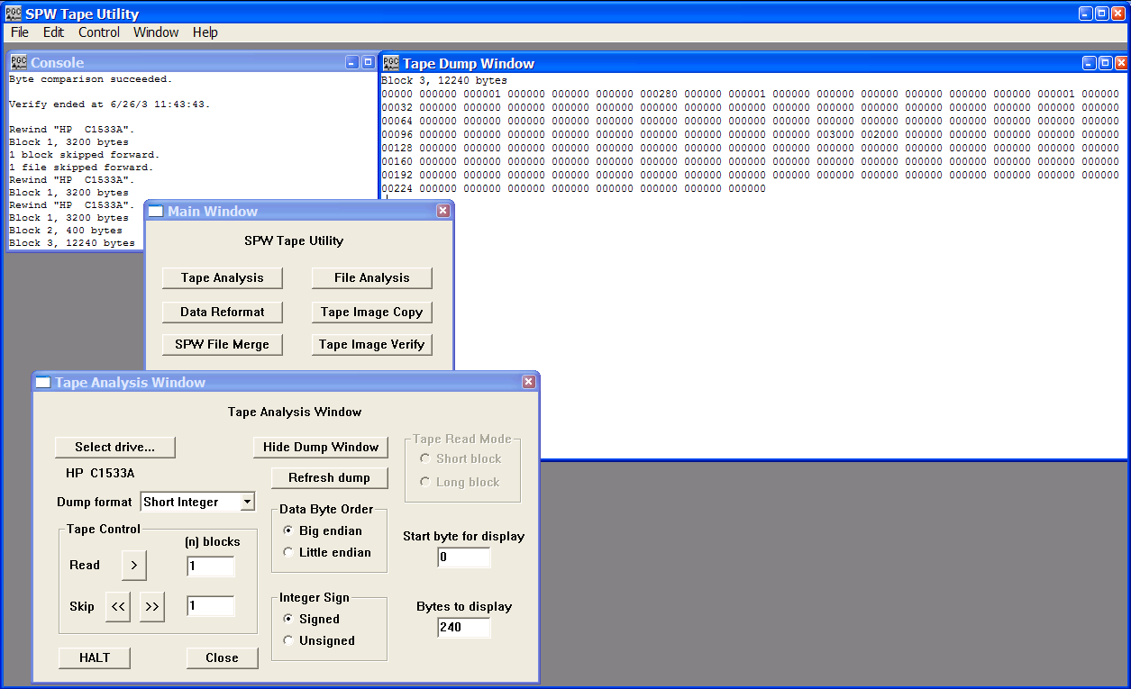
The Binary trace header displayed in the Tape Dump Window.

All 240-bytes of the SEG-Y binary trace header are assigned values that are described in the SEG-Y standard. The binary trace header displayed in the Tape Dump window in the figure above contains the trace information specific to the first data trace in the seismic file: (1) bytes 1-4 (bytes 3601-3604 in the file) indicate the trace sequence number in the line, in this case 1; (2) bytes 9-12 (bytes 3609-3612 in the file) indicate the field record number, in this case 280; (3) bytes 17-20 (bytes 3617-3620 in the file) would indicate the source point number, but are blank because we are analyzing raw field records; (4) bytes 21-24 (bytes 3621-3624 in the file) would indicate the CMP number of the data trace, but are blank because we are analyzing raw field records; (5) bytes 29-30 (bytes 3629-3630 in the file) indicate the trace identification code, in this case 1 (1 = seismic); (6) bytes 37-40 (bytes 3637-3640 in the file) would indicate the source-receiver offset, but are blank because we are analyzing raw field records. A complete description of the SEGY standard is available from the Society of Exploration Geophysicists.

Although 240-bytes of data were dumped to the File Dump Window, both the Console window and the File Dump Window display messages indicating that block 3 contained 12,240 bytes. The additional 12,000-bytes correspond to the trace data samples (3000 samples * 4 bytes/sample = 12,000 bytes). We chose not to display this information because our initial interest was in the binary trace header. To view the sample values corresponding to the first 40 samples of the data trace, change the Bytes to display value to 400 (240-bytes Trace Header + 40 samples * 4 bytes/sample = 400 bytes), set the dump format to IBM Float, the Data Byte order to Big endian (or as appropriate) and click on the refresh button to re-dump the data samples to the File Dump Window.

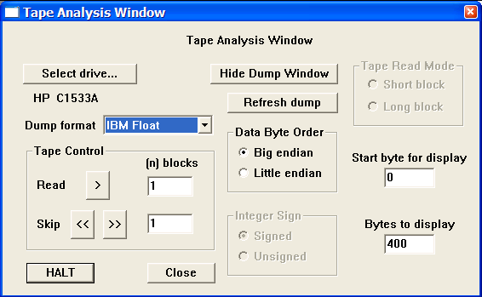
Preparing to read a SEG-Y trace data block.

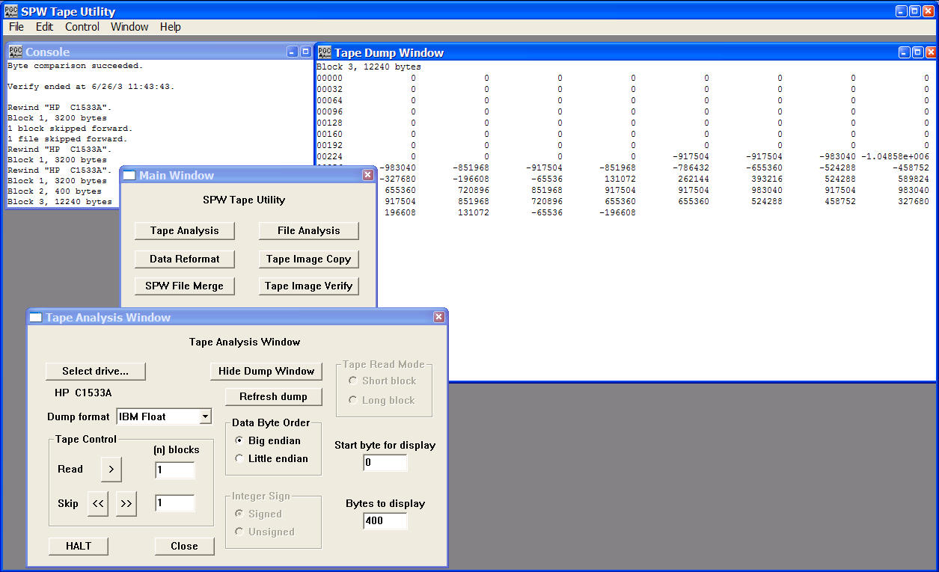
The trace header and the first 40 samples of trace data corresponding to trace 1 of the tape data file.

At this point, we have determined that the mandatory header values of the SEG-Y tape (number of traces per record, sample interval, samples per trace, format code, field file number, and trace number) are in the standard locations. The tape file may be successfully reformatted using the SEG-Y default parameterizations provided with IO Utility.

Example: SEG-D Format

The SEG-D format is really a family of seismic data acquisition formats that may be used to record both multiplexed and demultiplexed data. The original SEG-D tape standard was published in 1975 (Geophysics, 40, no. 02, 344-352) and has been revised twice to keep up with changes in the seismic data acquisition environment (Geophysics, 59, no. 04, 668-684; Geophysics, 62, no. 03, 1004-1031).

A basic SEG-D demultiplexed file format (fig. 2) consists of one or several 32-byte General Header blocks followed by one or several 32-byte Channel Set Descriptor blocks. The General Header blocks contain information specific to the seismic data in the file and the acquisition hardware used to acquire that data. An important aspect of the SEG-D family of formats is that SEG-D is self defining in the sense that information contained in the first General Header block specifies both the number of subsequent General Header blocks as well as the length of the data record. A Channel Set Descriptor block contains information specific to a single channel set, which is defined as a group of channels operating with identical recording parameters. The General Header and Channel Set Descriptor blocks are followed by the Channel sets, which consist of a number of 20-byte trace headers with their associated trace data samples. The trace headers contain basic information, such as field file number and channel number, which are specific to their associated seismic trace. There is one trace header per seismic data trace. For more information concerning the SEG-D Format standards, consult the SEG digital tape standards at:

http://seg.org/publications/tech-stand/

To analyze a SEG-D tape file, use the Select drive… button in the Tape Analysis window to open the Input Tape Select dialog. The Input Tape Select dialog is used to select an external tape drive that contains a physical tape with SEG-D data to be analyzed. Once the desired tape drive has been selected, click on the OK button in the upper right corner of the Input Tape Select dialog. The Tape Analysis window will display the name of the tape drive directly beneath the Select drive… button.

Figure 2. Schematic representation of a SEG-D file.
Input Tape Select Dialog

The tape drive containing a SEG-D tape file has been selected for analysis.

The SEG-D general header blocks contain information specific to their associated seismic data file, such as the field file number, the SEG-D format code, the time of shooting, the sampling interval, and the record length. As stated above, a SEG-D demultiplexed file consists of one or several 32-byte General Header blocks followed by one or several 32-byte Channel Set Descriptor blocks. The original SEG-D format had one general header block followed by one or several Channel Set Descriptor blocks. SEG-D revisions 1 and 2 contain a minimum of two general header blocks and allow for additional general header blocks should the need arise. The number of additional general header blocks is indicated in General Header block #1.
All values in the general header blocks are written as packed binary coded decimal, unless otherwise specified. To read the general header, set the dump format to Hexadecimal using the drop down menu, and instruct the Tape Analysis utility to display the first 32-bytes by entering <0> in the Start byte and <32> Bytes to display fields.

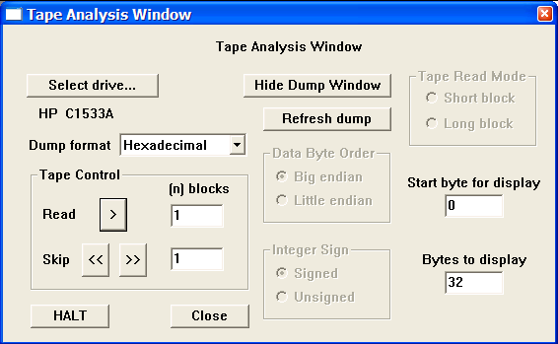
Preparing to read a the first SEG-D general header block.

To dump the currently selected 32-bytes of data to the Tape Dump Window, click on the READ > button in the Tape Control submenu. The dump window will appear with the contents of the first 32-byte general header.

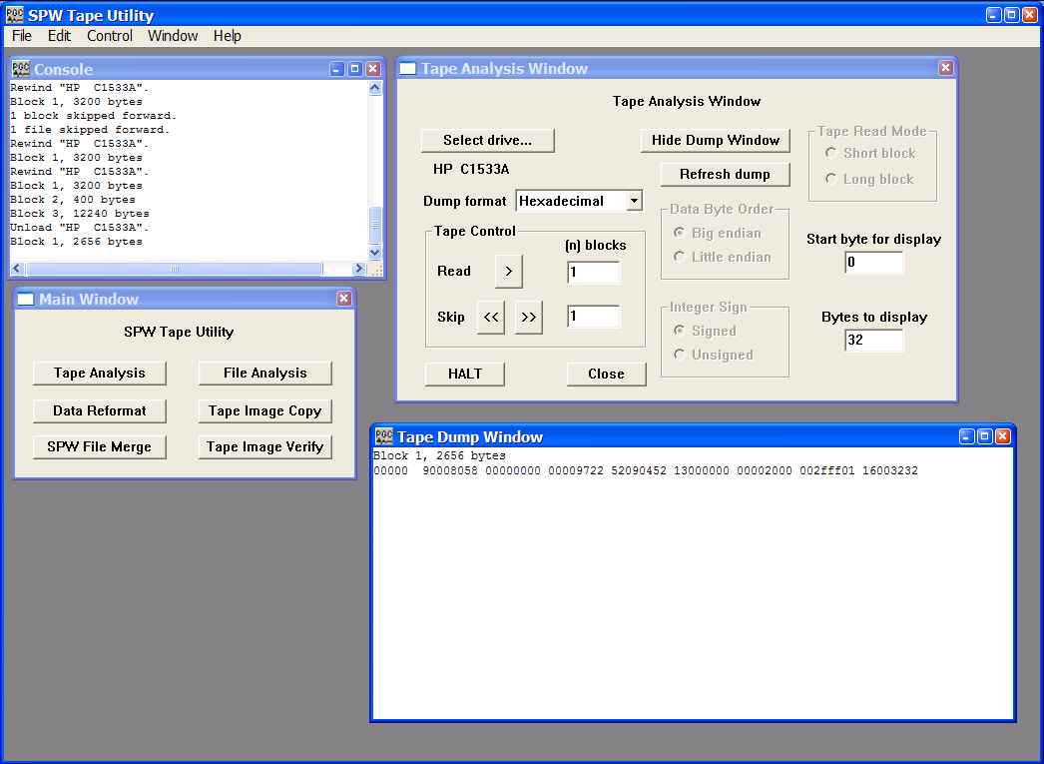
The first general header block displayed in the Tape Dump Window.

Each of the eight-character strings in the dump represents 4-bytes of the file. Eight strings equal 32-bytes. The SEG-D format code, 8058, in bytes 3-4, indicates that this file was written in one of the revised SEG-D formats (i. e. revision 1 or 2). SEG-D 8058 was not supported in the original SEG-D format description. In SEG-D 8058 data samples are written to tape as 32-bit IEEE demultiplexed floating point values. The file number (9000) is contained in bytes 1-2. The last two digits of the year (97), the Julian day (252), the hour (09), the minute (04), and the second (52) at the time of recording are contained in byte 11, byte 12 bits 5-8 and byte 13, byte 14, byte 15, and byte 16, respectively. The number of additional general header blocks (2) is contained in the first four bits of byte 12. This means that there are three general header blocks in total. The manufacturer code (Sercel) is contained in byte 17. The sample interval (2 ms) is coded as a binary number in byte 23. The ‘fff’ in byte 26 bits 5-8 and byte 27 indicates that the record length has been written in bytes 15-17 of general header block #2. The scan types per record (1) and number of channel sets per scan type (16) are contained in byte 28 and byte 29, respectively. Byte 30 indicates that there are no skew blocks. Byte 31 indicates that there are 32 extended header blocks, each of which is 32-bytes long. Byte 32 indicates that there are 32 external header blocks, each of which is 32-bytes long. In summary, general header block #1 reveals that there are a total of three general header blocks 16 channel set descriptor blocks, 32 extended header blocks, and 32 external header blocks prior to the first 20-byte trace header block. Therefore, the complete file header will be (3 General Header Blocks) * (32 bytes/block) + (16 Channel Set Descriptor Blocks) * (32 bytes/block) + (32 extended header blocks) * (32 bytes/block) + (32 external header blocks) * 32 bytes/block = 2656 bytes. This is confirmed by messages in both the Console and File Dump Window.

To dump the complete file header, just change the Bytes to display value to <2656> and refresh the dump.
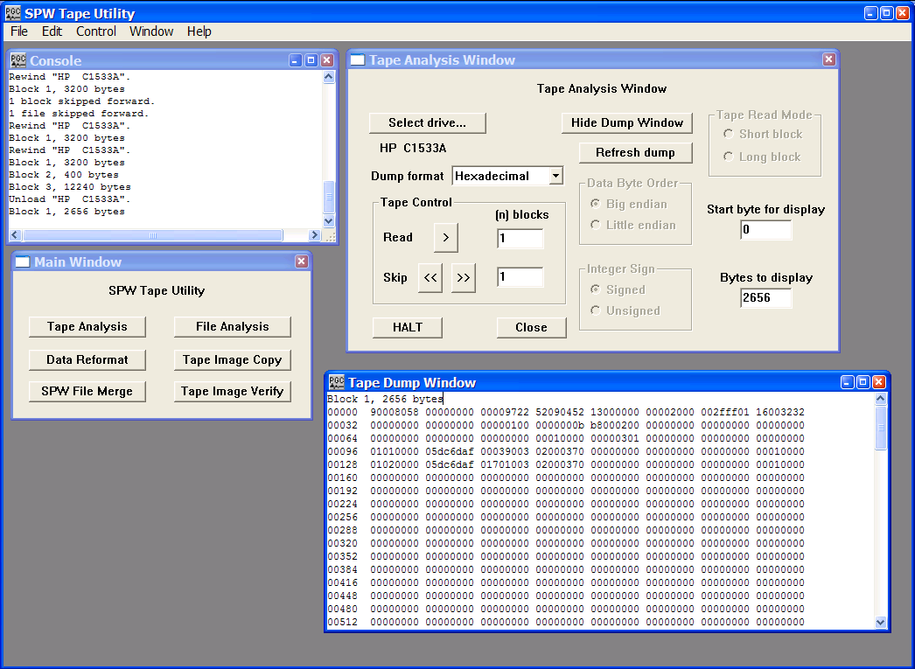
General header blocks 1, 2 and 3, and channel set descriptor blocks 1 through 16, and 24 of the external header blocks. Only the first two channel set descriptor blocks contain useful information.

The first 32 bytes of the dump are the contents of the first general header block. The next 32 bytes are the contents of the second general header block, which contain the SEG-D revision number (1) in byte 11, the record length (3000 ms) as a hexadecimal value (0bb8) in bytes 15-17, and the general header block number (2) in byte 19. Bytes 20-32 are not defined in revision 1 of the SEG-D format. The third line contains the contents of the third general header block, which contains the source point index (1) in byte 14, the general header block number (3) in byte 19, and the source set number (1) in byte 20. The fourth and fifth lines in the Tape Dump Window display the contents of the first two Channel Set Descriptor blocks. In each case the scan number is in byte 1 and the channel set is in byte 2. The number of channels in the channel set is contained in bytes 9-10. The channel type indicator is in the first 4 bits of byte 11. Channel set one consists of 3 auxiliary (9) channels and channel set two consists of 170 seismic (1) channels. The frequency of the anti-alias filter in Hertz and the roll-off of the filter in dB/octave are contained in bytes 13-14 and bytes 15-16, respectively. In each case, the frequency of the anti-alias filter is 200 Hz and the roll-off is 370 dB/octave. The value of 1 in byte 30 of the channel set descriptor blocks indicates that the traces are unstacked.
The Tape Analysis utility is currently positioned at byte 2656 (start of block 2) of the selected SEG-D tape file. This is the starting point of the 20-byte trace descriptor block corresponding to the first trace. To dump the trace header, set the dump format to Hexadecimal using the drop down menu, and instruct the Tape Analysis utility to display the first 20-bytes by entering <0> in the Start byte and <20> Bytes to display fields. Click on the READ > button to display the contents of the first trace descriptor block.

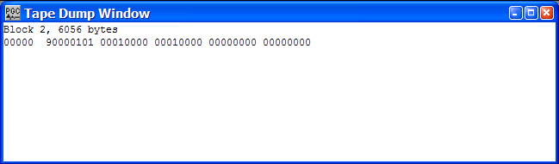
The contents of the first trace descriptor block.

The 20-byte trace header contains the file number (9000) in bytes 1-2, scan number (1) in byte 3, the channel set (1) in byte 4, the trace number (1) in bytes 5-6, and the number of 32-byte trace header extensions (1) in byte 10. To read the 32-byte trace header extension, just change the Bytes to display value to <52> (20-byte trace header block + 32-byte extension) and refresh the dump.
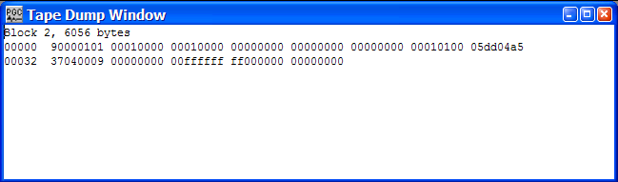

The contents of the first trace descriptor block and the trace header extension.

The 32-byte trace header extension contains information regarding the receiver point number (1), the receiver point index (1), and most importantly the number of samples per data trace (1501) coded as hexadecimal in bytes 8-10 (05dd). Therefore, the number of bytes in the second block – 6056 bytes – are in agreement with our analysis (20-byte Trace Descriptor Block + 32-byte Trace Header Extension + 1501 samples * 4 bytes/sample = 6056 bytes). Bytes 11-32 of the trace header extension are undefined by format and may take on any value.

To view the first 40 sample values corresponding to the first data trace, change the Bytes to display value to 212 (20-bytes Trace Descriptor Block + 32-byte Trace Header Extension + 40 samples * 4 bytes/sample = 212 bytes), set the dump format to IEEE Float, the Data Byte order to Big endian (or as appropriate) and click on the refresh button to re-dump the data samples to the File Dump Window.
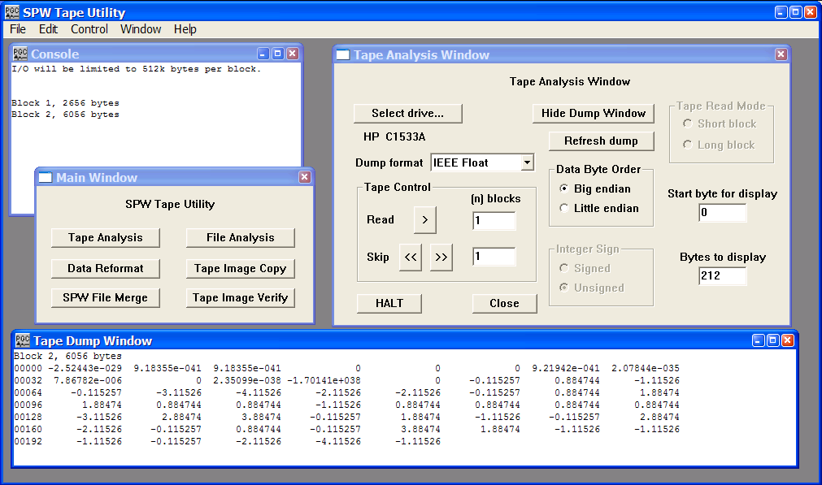
The 20-byte Trace Descriptor Block (as IEEE Floating-Point), the 32-byte Trace Header Extension (as IEEE Floating-Point), and the first 40 data samples from trace 1 of the first file.

At this point, we have determined that the mandatory header values of the SEG-D tape (number of traces per record, sample interval, samples per trace, format code, field file number, and trace number) are in the standard locations. The tape file may be successfully reformatted using the SEG-D default parameterizations provided with IO Utility.

File Analysis

The File Analysis utility is designed for the efficient analysis of disk files whose content is unknown or problematic. To use the file analysis utility, simply click on the File Analysis button in the Main Window and the File Analysis window will appear.
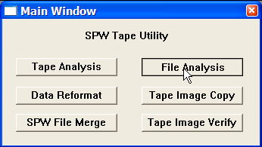
Main Window

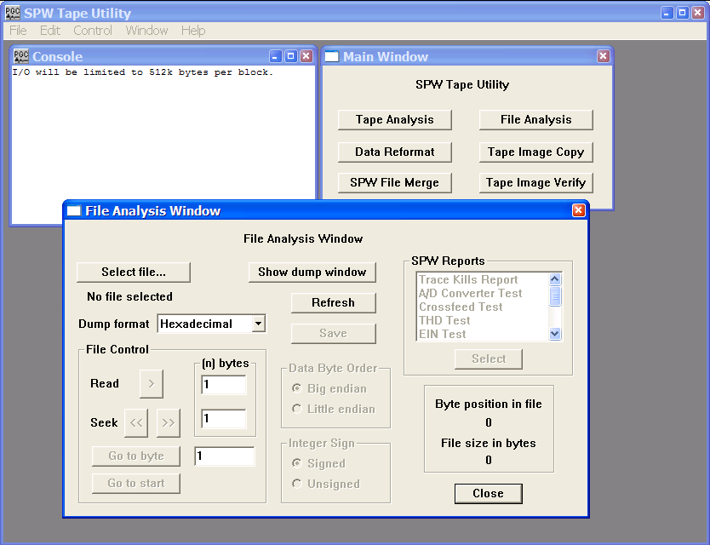
File Analysis Window

The remainder of the chapter will: (1) discuss the various features of the File Analysis window; (2) explain the number systems that the File Analysis utility is capable of interpreting; and (3) provide examples of the analysis of actual SEG-Y, SEG-D, and SEG-2 data files to determine the parameters necessary to reformat those files to SPW format.

File Analysis Window

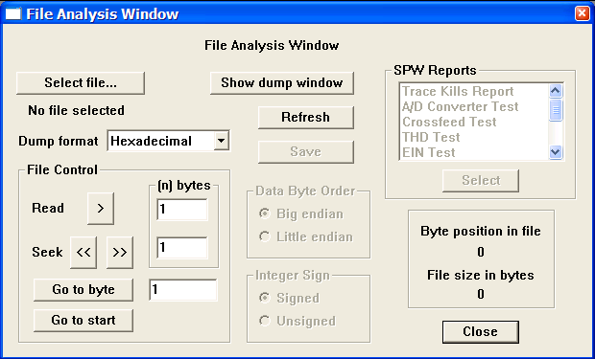
The File Analysis Window.

Parameter Dialog

Select file… The Select file button opens the Open Input Disk File dialog, which allows you to maneuver through the directory structure and locate an input file for analysis. Once a file has been selected, the file name will appear beneath the Select file… button.

Dump Format – A drop down menu is used to select the format in which the selected data will be dumped into the File dump window. Dump formats include Hexadecimal, ASCII, EBCDIC, Short Integer, Long Integer, IBM Float, and IEEE Float.

Show dump window - The Show dump window button is a toggle that allows the dump window to be displayed or hidden. When the Show dump window button is clicked, the File dump window appears and the button toggles to the Hide dump window button.

Refresh – The Refresh button is used to redump the same block of data after changing the dump format. This allows you to analyze the same block of data in several formats without returning repeatedly to the same starting byte.

Save – Allows the current contents of the File dump window to be saved as a text file.

File Control – The File Control commands are used to control the position of the File Analysis utility in the currently selected data file.

Read > Clicking the Read button cause the number of bytes entered in the Read parameter field to be dumped to the File dump window. The dump starts at the current byte position.

Seek << >> Clicking the Seek button advance or reverses the current byte position of the File Analysis utility by the number of bytes entered in the Seek parameter field.

Go to byte Clicking the Go to byte command positions the File Analysis utility at the byte position entered into the Go to byte field.

Go to start Clicking the Go to start command positions the File Analysis utility at the first byte of the selected file.

Byte position in file – Indicates the byte position at which the File Analysis utility is currently located.

File size in bytes - Indicates the size of the currently selected file in bytes.

Data Byte Order

Big endian – If checked, the File Analysis utility will read integer values in big endian byte order. In big endian byte order the most significant byte of the integer value is stored in the first, or lowest data address.

Little endian - If checked, the File Analysis utility will read integer values in little endian byte order. In little endian byte order the least significant byte of the integer value is stored in the first, or lowest data address.

For example, the 4-byte integer representation of the decimal value 2049 (2¹¹ +1) is:

00000000 00000000 00001000 00000001

When written to file as a sequence of 1-byte (8-bit) entries, the big- and little-endian representations are as follows:

Byte | Big-endian | Little-endian
0 | 00000000 | 00000001
1 | 00000000 | 00001000
2 | 00001000 | 00000000
3 | 00000001 | 00000000
Integer Sign

Signed – If checked, integer values will be read as signed, implying that when the value was written to the file a sign bit was coded.

Unsigned - If checked, integer values will be read as unsigned, implying that when the value was written to the file a sign bit was not coded.

For example, a signed Short Integer (2-bytes) will use 1 bit for a sign bit and 15 bits to store the sample value. Therefore, the possible range of data values is –2¹⁵ to 2¹⁵-1, or –32,768 to 32,767. An unsigned Short Integer (2-bytes) will use all 16 bits to store the sample value. Therefore, the possible range of data values is 0 to 2¹⁶-1, or 65,535.

SPW Reports – The SPW Reports dialog is used to generates diagnostic reports from SPW formatted data. Reports can only be generated from SPW data. Report formats include:

Trace Kills Report – The Trace Kills Report is used to generate a list of traces that have been killed (1) during application of the geometry; (2) by processing steps such as Kill Traces and Automatic Trace Edits; (3) interactively in SeisViewer.

A/D Converter Test – The A/D Converter test measures the accuracy of the recording instruments.

Crossfeed Test – The Crossfeed test measures the amount of electrical interference that is present in each channel of the recording instrument due to a known signal driven on adjacent channels.

THD Test – The Harmonic Distortion (HR) test measures the recording accuracy of the recording instrument as a function of frequency.

EIN Test – The Equivalent Input Noise (EIN) test measure the amount of noise generated by the electronic components of the recording instrument.

DC Offset Test – The DC Offset test measures the amount of DC bias (in microvolts) that is present in each channel of the recording instrument.

Dynamic Range Test – The Dynamic Range test measures the recording range of a signal input to the recording instrument above the noise level of the recording instrument.

Impulse Response Test – The Impulse Response test measures the impulse response of the recording system by sending a pulse through that system and recording the response.

Gain Accuracy Test – The Gain Accuracy test provides a measure of the accuracy of the amplifiers in the recording instrument.

Gain Step Test – The Gain Step test provides a measure of the accuracy of the amplifiers in the recording instrument.

For a complete discussion of each of the SPW Report types, consult the section on SPW Reports below.

Note on Number Systems

The File Analysis utility is designed to dump binary information coded into the byte structure of a file in the following formats:

Hexadecimal
ASCII
EBCDIC
Short Integer
Long Integer
IBM Float
IEEE Float

The hexadecimal number system is used to compactly represent binary numbers. ASCII and EBCDIC are codes for representing English characters as numbers on a computer. Integer numbers are whole numbers that do not contain a fractional part. Floating-point numbers are real numbers that contain a fractional part. Floating-point numbers are always expressed as

Floating point number = (sign)*(fraction)*(base ^{exponent-bias}).

Each of these variable types will be discussed briefly.

Hexadecimal – The hexadecimal number system is a base 16 system that uses the values 0-9 and A-F to represent decimal numbers. Hexadecimal values are often display with the suffix “H”, such a 33a5H for the value 33a5. The following chart displays the conversion between decimal, binary, and hexadecimal.

Decimal | Binary | Hexadecimal
0 | 0000 | 00H
1 | 0001 | 01H
2 | 0010 | 02H
3 | 0011 | 03H
4 | 0100 | 04H
5 | 0101 | 05H
6 | 0110 | 06H
7 | 0111 | 07H
8 | 1000 | 08H
9 | 1001 | 09H
10 | 1010 | 0AH
11 | 1011 | 0BH
12 | 1100 | 0CH
13 | 1101 | 0DH
14 | 1110 | 0EH
15 | 1111 | 0FH
16 | 1 0000 | 10H
Decimal-binary-hexadecimal conversion chart.

ASCII – ASCII is shorthand for American Standard Code for Information Interchange. The ASCII code was designed to represent English characters as numbers on a computer. In modern usage, ASCII is a byword for raw, text-only files.

EBCDIC – EBCDIC is shorthand for Extended Binary Coded Decimal Interchange Code. The EBCDIC code was designed by IBM to represent English characters as numbers on a computer. The EBCDIC code is used to store information in the SEG Y reel header.

Short Integers – A two-byte integer value that may be signed or unsigned. If signed, 1 bit is allocated for a sign bit and 15 bits are allocated to store the sample value. Therefore, the possible range of data values for a signed Short Integer is –2¹⁵ to 2¹⁵-1, or –32,768 to 32,767. If unsigned, all 16 bits are allocated to store the sample value. Therefore, the possible range of data values for an unsigned Short Integer is 0 to 2¹⁶-1, or 65,535.

Long Integers – A four-byte integer value that may be signed or unsigned. If signed, 1 bit is allocated for a sign bit and 31 bits are allocated to store the sample value. Therefore, the possible range of data values for a signed Long Integer is –2³¹ to 2³¹-1, or –2,147,483,648 to 2,147,483,647. If unsigned, all 32 bits are allocated to store the sample value. Therefore, the possible range of data values for an unsigned Long Integer is 0 to 2³²-1, or 4,294,967,296.

IBM Float – A floating point format in which contains 1 sign bit, 7 bits for the exponent, and 24 bits for the fraction.

IEEE Float – A floating point format in which contains 1 sign bit, 8 bits for the exponent, and 23 bits for the fraction.

SPW Reports

SPW Reports – The SPW Reports dialog is used to generate diagnostic reports from SPW formatted data. All report types are output to the File Dump Window, from where they can be saved as a text file using the Save command in the File Analysis Window. The currently available selection of report formats is divided into two groups: (1) Trace Kills reports, and (2) Instrument Test reports.

The Instrument Tests consist of the following:

A/D Converter Test – The A/D Converter test measures the accuracy of the recording instruments.

Crossfeed Test – The Crossfeed test measures the amount of electrical interference that is present in each channel of the recording instrument due to a known signal driven on adjacent channels.

THD Test – The Harmonic Distortion (HR) test measures the recording accuracy of the recording instrument as a function of frequency.

EIN Test – The Equivalent Input Noise (EIN) test measure the amount of noise generated by the electronic components of the recording instrument.

DC Offset Test – The DC Offset test measures the amount of DC bias (in microvolts) that is present in each channel of the recording instrument.

Dynamic Range Test – The Dynamic Range test measures the recording range of a signal input to the recording instrument above the noise level of the recording instrument.

Impulse Response Test – The Impulse Response test measures the impulse response of the recording system by sending a pulse through that system and recording the response.

Gain Accuracy Test – The Gain Accuracy test provides a measure of the accuracy of the amplifiers in the recording instrument.

Gain Step Test – The Gain Step test provides a measure of the accuracy of the amplifiers in the recording instrument.

Trace Kills Report – The Trace Kills Report is used to generate a list of the traces that have been killed (1) during geometry application; (2) by FlowChart processing steps such as Kill Traces and Automatic Trace Edits; (3) interactively in SeisViewer. To generate a trace kill report, select an SPW formatted file with the Select File… button and then select Trace Kills Report in the SPW Reports window. Clicking on the Select button will open the Trace Kills Report dialog, which will allow you to choose one or all of the following report types: (1) Geometry Kills, (2) Processing Kills, (3) Other Kills.
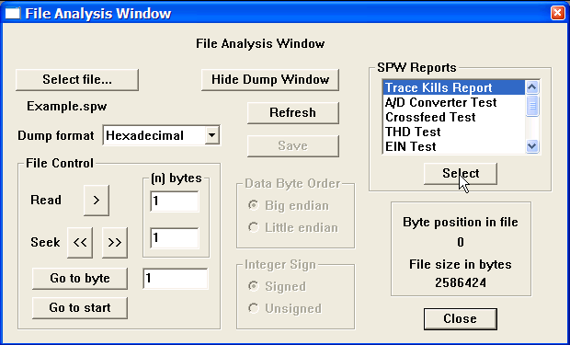
Select Trace Kills Report from the SPW Reports menu.

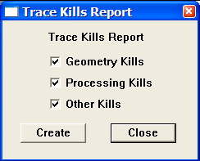
Select the report type from the Trace Kills Report dialog.

Parameter Dialog

Geometry Kills – If checked, a list of traces killed by the Geometry step in FlowChart will be output in the Trace Kills Report.

Processing Kills – If checked, a list of traces killed during processing in FlowChart will be output in the Trace Kills Report.

Other Kills – If checked, a list of traces killed interactively in SeisViewer will be output in the Trace Kills Report.

Once you have selected the type of trace kill report to generate, click on Create, and the report will be sent to the File Dump Window. To save the report as a raw text file, use the Save command in the File Analysis Window.
A/D Converter Test – The A/D Converter test measures the accuracy of the recording instruments. The test analyses a suite of known constant voltages that are fed through the instrument. The accuracy with which these voltages are recorded is a measure of the accuracy of the instruments analog-to-digital converter. Records input to the test must be organized such that the voltages in each successive record either double in value or are reduced by half. As with all of the instrument tests, the results of the A/D converter test are either pass or fail. The output of the test is sent to the File Dump Window and a failure message is issued if any portion of the test fails. A warning message is issued if the records are not stored in floating-point format.

To generate an A/D Converter Test report, select an SPW formatted file with the Select File… button and then select A/D Converter Test in the SPW Reports window. Clicking on the Select button will open the A/D Converter Test dialog, which requires the user to enter: (1) the voltage value of the first record in the test, (2) whether the voltages in subsequent records will increase or decrease, and (3) the channels on which constant voltage measurements have been made.

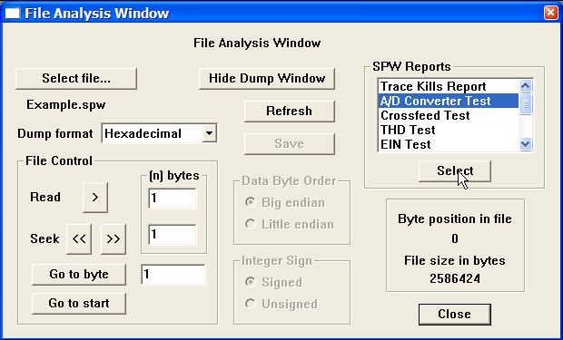
Select A/D Converter Test from the SPW Reports menu.
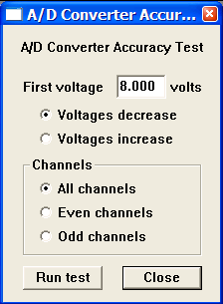
A/D Converter Accuracy Test dialog.

Parameter Dialog

First voltage – Enter the value of the constant voltage measured by the first record input to the A/D Converter Accuracy test.

Voltages decrease – If checked, indicates that the voltage measured by the second record of the test will be half the value of the first record, the voltage measured by the third record of the test will be one fourth the value of the first record, etc.

Voltages increase – If checked, indicates that the voltage measured by the second record of the test will be twice the value of the first record, the voltage measured by the third record of the test will be four times the value of the first record, etc.

Channels – Indicate the channels on which the constant voltage measurements have been made.

All channels – If checked, indicates that all channels of the input records contain A/D converter test records.

Even channels – If checked, indicates that only the even channels of the input records contain A/D converter test records.

Odd channels – If checked, indicates that only the odd channels of the input records contain A/D converter test records.

Once you completed the parameterization of the A/D Converter Test dialog, click on Run Test, and the report will be sent to the File Dump Window. To save the report as a raw text file, use the Save command in the File Analysis Window.

Crossfeed Test – The Crossfeed test measures the amount of electrical interference that is present in each channel of the recording instrument due to a known signal on adjacent channels. The test requires that the user enter (1) the field file that contains the input data for the test, (2) the range of channels to test on that field file, (3) the dB of isolation that is acceptable for the instrument being tested, and (4) whether the DC bias is to be removed (the default) from the input data prior to measuring crossfeed. As with all of the instrument tests, the results of the Crossfeed test are either pass or fail. The output of the test is sent to the File Dump Window and a failure message is issued if any portion of the test fails. A warning message is issued if the records are not stored in floating-point format.

Reference:

The equation used to calculated crossfeed isolation is:

Crossfeed isolation (in dB) = 20log₁₀(Average RMS of signal traces / RMS of noise trace)

SEG Technical Standards Committee, 1988, Digital Seismic Recorder Specification Standards: Society of Exploration Geophysics.

Sercel Inc., 1989, SN 368 Manual: Sercel Inc.

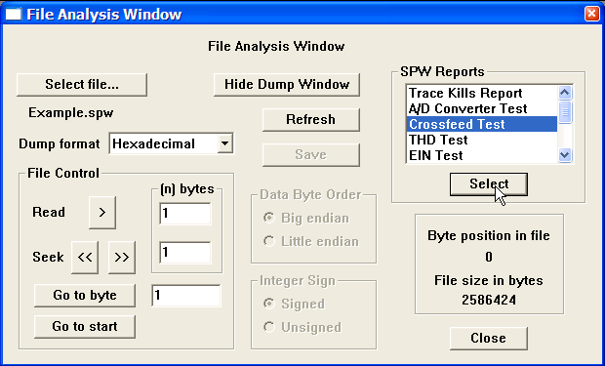
Select Crossfeed Test from the SPW Reports menu.
Crossfeed Test dialog.
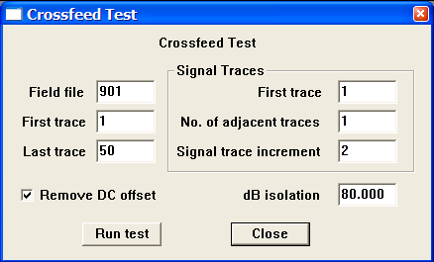
Parameter Dialog

Field file – Enter the number of the field file that contains the crossfeed measurements.

First trace – Enter the number of the first trace in the field file that contains the crossfeed measurements.

Last trace – Enter the number of the last trace in the field file that contains the crossfeed measurements.

Signal Traces – Indicate the traces on which the known signal has been recorded.

First trace – Enter the number of the first trace in the record that contains a record of the known signal.

No. of adjacent traces – Enter the number of adjacent traces in the record that contain a record of the known signal.

Signal trace increment – Enter the increment between traces in the record that contain a record of the known signal.

Example: In the Crossfeed Test dialog above, signal traces would be located on channels 1, 3, 5, 7, …….49 of field file 901.

Remove DC offset – If checked, the DC bias will be removed from each trace in the Crossfeed test record prior to the calculation of crossfeed.

dB isolation – Enter the value, in units of decibels, that characterizes the isolation from electrical interference of each channel relative to neighboring channels for the recording system being tested.

Once you completed the parameterization of the Crossfeed Test dialog, click on Run Test, and the report will be sent to the File Dump Window. To save the report as a raw text file, use the Save command in the File Analysis Window.
THD Test – The Total Harmonic Distortion (THD) test measures the recording accuracy of the recording instrument as a function of frequency. The test requires that the user enter (1) the field file that contains the sine wave input data for the test, (2) the range of channels to test in that field file, (3) the maximum total harmonic distortion allowable for the instrument being tested, (4) number of harmonics of the fundamental frequency used in the test and output in the THD report, (5) whether the DC bias is to be removed (the default) from the input data prior to measuring harmonic distortion, and (6) whether to calculate harmonic distortion in the time domain or in the frequency domain. As with all of the instrument tests, the results of the THD test are either pass or fail. The output of the test is sent to the File Dump Window and a failure message is issued if any portion of the test fails. A warning message is issued if the records are not stored in floating-point format.

Reference:

The equations used to calculated harmonic distortion and total harmonic distortion are:

Harmonic distortion = Amplitude at harmonic / Amplitude at fundamental

Total harmonic distortion = square root{[sum of (Amp. at harmonic^2)] / (Amp. at fundamental^2)}

SEG Technical Standards Committee, 1988, Digital Seismic Recorder Specification Standards: Society of Exploration Geophysics.

Sercel Inc., 1989, SN 368 Manual: Sercel Inc.

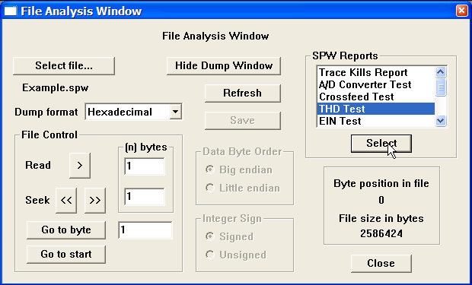

Select THD Test from the SPW Reports menu.
Harmonic Distortion Test dialog.
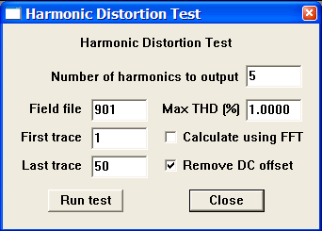
Parameter Dialog

Field file – Enter the number of the field file that contains the sine wave measurements.

First trace – Enter the number of the first trace in the field file that contains the sine wave measurements.

Last trace – Enter the number of the last trace in the field file that contains the sine wave measurements.

Number of harmonics to output – Enter the number of harmonics of the fundamental frequency used in the test and output in the THD report.

Max THD (%) – Enter the maximum acceptable total harmonic distortion, as a percent of the fundamental frequency, for the instrument being tested.

Calculate using FFT – If checked, both the harmonic distortion and the total harmonic distortion will be calculated in the Fourier domain.

Remove DC Offset – If checked, the DC bias will be removed from each trace of the sine wave input data prior to the calculation of harmonic distortion.

Once you completed the parameterization of the Harmonic Distortion Test dialog, click on Run Test, and the report will be sent to the File Dump Window. To save the report as a raw text file, use the Save command in the File Analysis Window.

EIN Test – The Equivalent Input Noise (EIN) test measures the amount of noise generated by the electronic components of the recording instrument. The test requires that the user enter (1) the field file that contains the input data for the test, (2) the range of channels to test in that field file, (3) the maximum RMS noise level, in microvolts, that is acceptable for the instrument being tested, and (4) whether the DC bias is to be removed (the default) from the input data prior to calculating electronic noise. As with all of the instrument tests, the results of the EIN test are either pass or fail. The output of the test is sent to the File Dump Window and a failure message is issued if any portion of the test fails. A warning message is issued if the records are not stored in floating-point format.

Reference:

The equation used to calculated the Equivalent Noise input level is:

Noise level = square root( RMS(data)^2 - Average(data)^2 )

SEG Technical Standards Committee, 1988, Digital Seismic Recorder Specification Standards: Society of Exploration Geophysics.

Sercel Inc., 1989, SN 368 Manual: Sercel Inc.

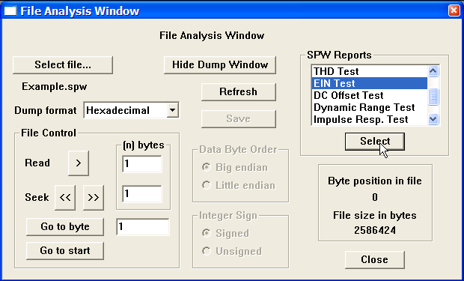
Select EIN Test from the SPW Reports menu.

Equivalent Input Noise Test dialog.
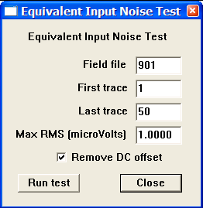
Parameter Dialog

Field file – Enter the number of the field file that contains the input data.

First trace – Enter the number of the first trace in the field file that contains the input data.

Last trace – Enter the number of the last trace in the field file that contains the input data.

Max RMS (microVolts) – Enter the maximum allowable RMS noise level for the instrument being tested.

Remove DC Offset – If checked, the DC bias will be removed from each trace of the input data prior to the calculation of the noise level.

Once you completed the parameterization of the Equivalent Input Noise Test dialog, click on Run Test, and the report will be sent to the File Dump Window. To save the report as a raw text file, use the Save command in the File Analysis Window.

DC Offset Test – The DC Offset test measures the amount of DC offset (bias) in units of microvolts that is present on each channel of the recording instrument. The test requires that the user enter (1) the field file that contains the input data for the test, (2) the range of channels to test in that field file, and (3) the maximum DC Offset in microvolts acceptable for the instrument being tested. As with all of the instrument tests, the results of the DC Offset test are either pass or fail. The output of the test is sent to the File Dump Window and a failure message is issued if any portion of the test fails. A warning message is issued if the records are not stored in floating-point format.

Reference:

The equation used to calculated the DC Offset is:

DC Offset = Sum of Data / Number of data samples

SEG Technical Standards Committee, 1988, Digital Seismic Recorder Specification Standards: Society of Exploration Geophysics.

Sercel Inc., 1989, SN 368 Manual: Sercel Inc.

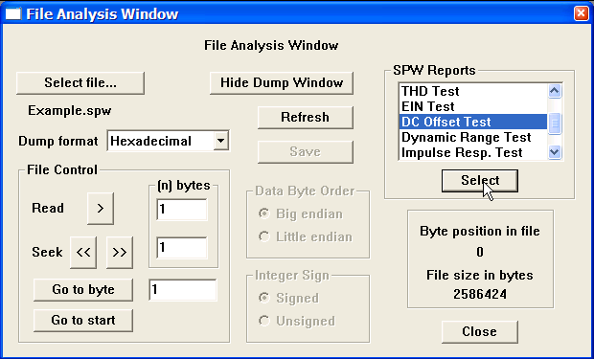
Select DC Offset Test from the SPW Reports menu.
DC Offset Test dialog.
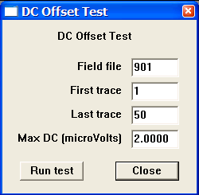
Parameter Dialog

Field file – Enter the number of the field file that contains the input data.

First trace – Enter the number of the first trace in the field file that contains input data.

Last trace – Enter the number of the last trace in the field file that contains input data.

Max DC (microVolts) – Enter the maximum allowable DC offset in microvolts for the instrument being tested.

Once you completed the parameterization of the DC Offset Test dialog, click on Run Test, and the report will be sent to the File Dump Window. To save the report as a raw text file, use the Save command in the File Analysis Window.

Dynamic Range Test – The Dynamic Range test measures the recording range of a signal input to the recording instrument above the noise level of the recording instrument. The test requires that the user enter (1) the field file that contains the signal records for the test, (2) the field file that contains the noise records for the test, (3) the range of channels to test in the signal and noise files, and (4) the minimum dynamic range acceptable for the instrument being tested, and (5) whether the DC bias is to be removed (the default) from the input data prior to calculating dynamic range. As with all of the instrument tests, the results of the Dynamic Range test are either pass or fail. The output of the test is sent to the File Dump Window and a failure message is issued if any portion of the test fails. A warning message is issued if the records are not stored in floating-point format.

Reference:

The equation used to calculated the dynamic range is:

Dynamic Range (dB) = 20log₁₀ ( RMS(Signal trace) / RMS(Noise trace) )

SEG Technical Standards Committee, 1988, Digital Seismic Recorder Specification Standards: Society of Exploration Geophysics.

Sercel Inc., 1989, SN 368 Manual: Sercel Inc.

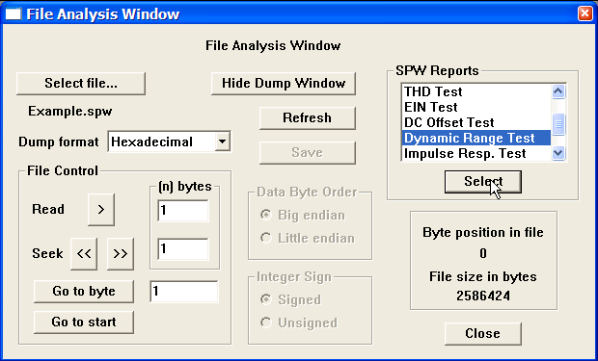
Select Dynamic Range Test from the SPW Reports menu.

Dynamic Range Test dialog.
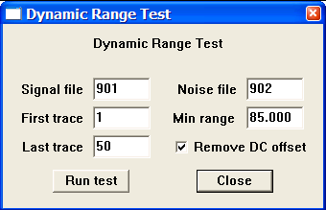
Parameter Dialog

Signal file – Enter the number of the field file that contains the signal data.

Noise file – Enter the number of the field file that contains the noise data.

First trace – Enter the number of the first trace in the field files that contains signal and noise data.

Last trace – Enter the number of the last trace in the field files that contains signal and noise data.

Min range – Enter the minimum acceptable dynamic range for the instrument being tested.

Remove DC Offset – If checked, the DC bias will be removed from each trace of the input data prior to the calculation of dynamic range.

Once you completed the parameterization of the Dynamic Range Test dialog, click on Run Test, and the report will be sent to the File Dump Window. To save the report as a raw text file, use the Save command in the File Analysis Window.

Impulse Response Test – The Impulse Response test measures the impulse response of the recording system by sending a pulse through that system and recording the response. The test requires that the user enter (1) the field file that contains the pulse data for the test, (2) the range of channels to test in that field file, and (3) the maximum allowable percentage of variation between a pulse recorded on any single channel and the average pulse computed from all the channels. As with all of the instrument tests, the results of the Impulse Response test are either pass or fail. The output of the test is sent to the File Dump Window and a failure message is issued if any portion of the test fails. A warning message is issued if the records are not stored in floating-point format.

Reference:

The equation used to calculate the impulse response variation is:

Impulse variation = RMS(data – average of all data) / RMS(average of all data)

SEG Technical Standards Committee, 1988, Digital Seismic Recorder Specification Standards: Society of Exploration Geophysics.

Sercel Inc., 1989, SN 368 Manual: Sercel Inc.

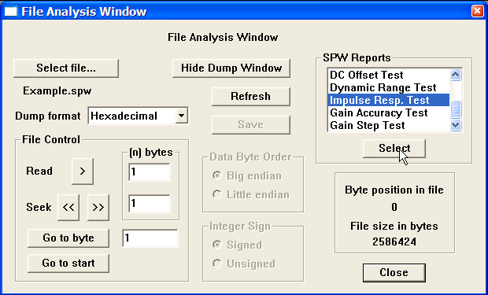
Select Impulse Response Test from the SPW Reports menu.
Impulse Response Test dialog.
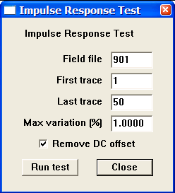
Parameter Dialog

Field file – Enter the number of the field file that contains the pulse data.

First trace – Enter the number of the first trace in the field file that contains pulse data.

Last trace – Enter the number of the last trace in the field file that contains pulse data.

Max variation (%) – Enter the maximum allowable percentage of variation between a pulse recorded on any single channel and the average pulse computed from all the channels being tested.

Remove DC Offset – If checked, the DC bias will be removed from each trace of the input data prior to the calculation of impulse variation.

Once you completed the parameterization of the Impulse Response Test dialog, click on Run Test, and the report will be sent to the File Dump Window. To save the report as a raw text file, use the Save command in the File Analysis Window.

Gain Accuracy Test – The Gain Accuracy test provides a measure of the accuracy of the amplifiers in the recording instrument. The test requires that the user enter (1) the field file that contains the input data for the test, (2) the range of channels to test in that field file, (3) the RMS voltage level input to the channels on the test record, and (4) the maximum acceptable variation in the input RMS voltage level for the instrument being tested. As with all of the instrument tests, the results of the Gain Accuracy test are either pass or fail. The output of the test is sent to the File Dump Window and a failure message is issued if any portion of the test fails. A warning message is issued if the records are not stored in floating-point format.

Reference:

The equation used to calculate the impulse response variation is:

Gain variation = ( RMS(data) – oscillator voltage level ) / oscillator voltage level

SEG Technical Standards Committee, 1988, Digital Seismic Recorder Specification Standards: Society of Exploration Geophysics.

Sercel Inc., 1989, SN 368 Manual: Sercel Inc.

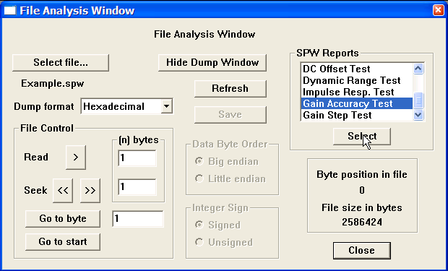
Select Gain Accuracy Test from the SPW Reports menu.
Gain Accuracy Test dialog.
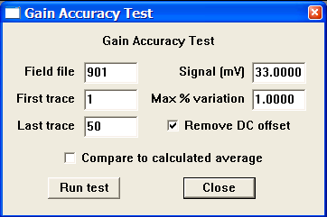
Parameter Dialog

Field file – Enter the number of the field file that contains the gain data.

First trace – Enter the number of the first trace in the field file that contains gain data.

Last trace – Enter the number of the last trace in the field file that contains gain data.

Signal (mV) – Enter the RMS voltage level input to the channels on the test record.

Max % variation – Enter the maximum acceptable variation, as a percent of the input RMS voltage level.

Remove DC Offset – If checked, the DC bias will be removed from each trace of the input data prior to the calculation of impulse variation.

Compare to calculated average – If checked, the gain variation calculation will be made between each trace and the calculated average voltage level - as opposed to the value entered in Signal (mV) - input to each trace.

Once you completed the parameterization of the Gain Accuracy Test dialog, click on Run Test, and the report will be sent to the File Dump Window. To save the report as a raw text file, use the Save command in the File Analysis Window.
Gain Step Test – The Gain Step test provides a measure of the accuracy of the amplifiers in the recording instrument. The test requires that the user enter (1) a field file that contains input data for the test, (2) a second field file that contains input data for the test, (3) the range of channels to test in those field files, (4) the maximum acceptable variation in the input RMS voltage level for the instrument being tested. As with all of the instrument tests, the results of the Gain Step test are either pass or fail. The output of the test is sent to the File Dump Window and a failure message is issued if any portion of the test fails. A warning message is issued if the records are not stored in floating-point format.

Reference:

SEG Technical Standards Committee, 1988, Digital Seismic Recorder Specification Standards: Society of Exploration Geophysics.

Sercel Inc., 1989, SN 368 Manual: Sercel Inc.

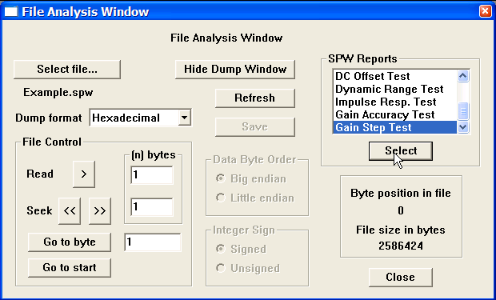
Select Gain Step Test from the SPW Reports menu.
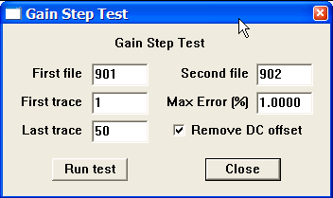
Gain Step Test dialog.

Parameter Dialog

First file – Enter the number of the first field file that contains the gain data.

Second file – Enter the number of the second field file that contains the gain data.

First trace – Enter the number of the first trace in the field files that contains gain data.

Last trace – Enter the number of the last trace in the field files that contains gain data.

Max Error (%) – Enter the maximum acceptable variation, as a percent of the input RMS voltage level.

Remove DC Offset – If checked, the DC bias will be removed from each trace of the input data prior to the calculation of impulse variation.

Once you completed the parameterization of the Gain Step Test dialog, click on Run Test, and the report will be sent to the File Dump Window. To save the report as a raw text file, use the Save command in the File Analysis Window.

Example: SEG-Y Format

The SEG-Y format is a demultiplexed seismic data format that consists of a 3600-byte reel identification header followed by trace data blocks (fig.1). The reel identification header consists of a 3200-byte EBCDIC (Extended Binary Coded Decimal Interchange Code) text file header and a 400-byte binary file header. Each of these two blocks contains information specific to the seismic data in the file. The trace data block consists of a 240-byte binary coded trace identification header followed by the trace data samples. There is one trace identification header per trace. For more information concerning the SEG-Y Format standard, consult the SEG digital tape standards at

http://seg.org/publications/tech-stand/

To analyze a SEGY file, use the Select file… button in the File Analysis window to open the Open Input Disk File dialog. The Open Input Disk File dialog is used to maneuver through the directory structure and select a SEG-Y data file for analysis. After the desired SEG-Y file has been selected, click on the Open button in the lower right corner of the Open Input Disk File dialog. Once the SEG-Y file is selected, the File Analysis window will display: (1) the name of the file directly beneath the Select file… button; (2) the size of the file, in bytes, in the lower right corner; (3) and the byte position in the file at which the File Analysis utility is currently pointed.

Figure 1. Schematic representation of a SEG-Y data file.

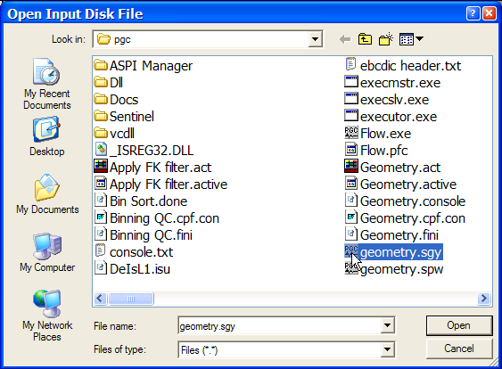
Open Input Disk file Dialog
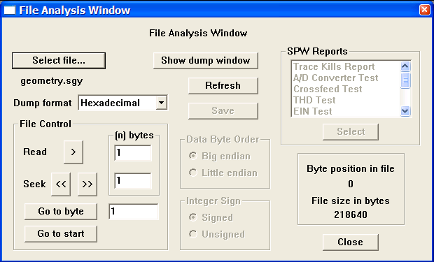
SEG-Y file selected for analysis. Byte position in the file and the file size, in bytes, are displayed in lower right corner.

A great deal of information can be extracted from a properly written SEG-Y reel header. As stated above, the reel header consists of a 3200-byte EBCDIC text header and a 400-byte binary header. To read the EBCDIC header, set the dump format to EBCDIC using the drop down menu, and instruct the File Analysis utility to read the first 3200-bytes by entering this value in the parameter field to the right of the Read button in the File Control submenu.
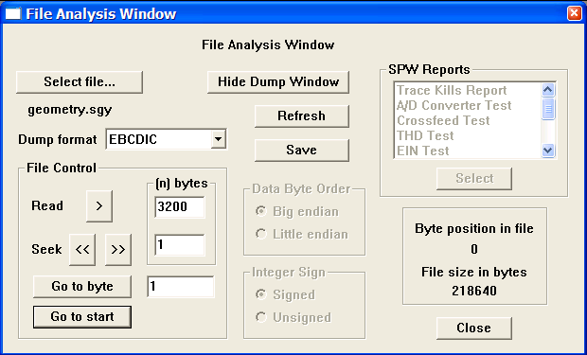
Preparing to read a SEG-Y EBCDIC reel header.

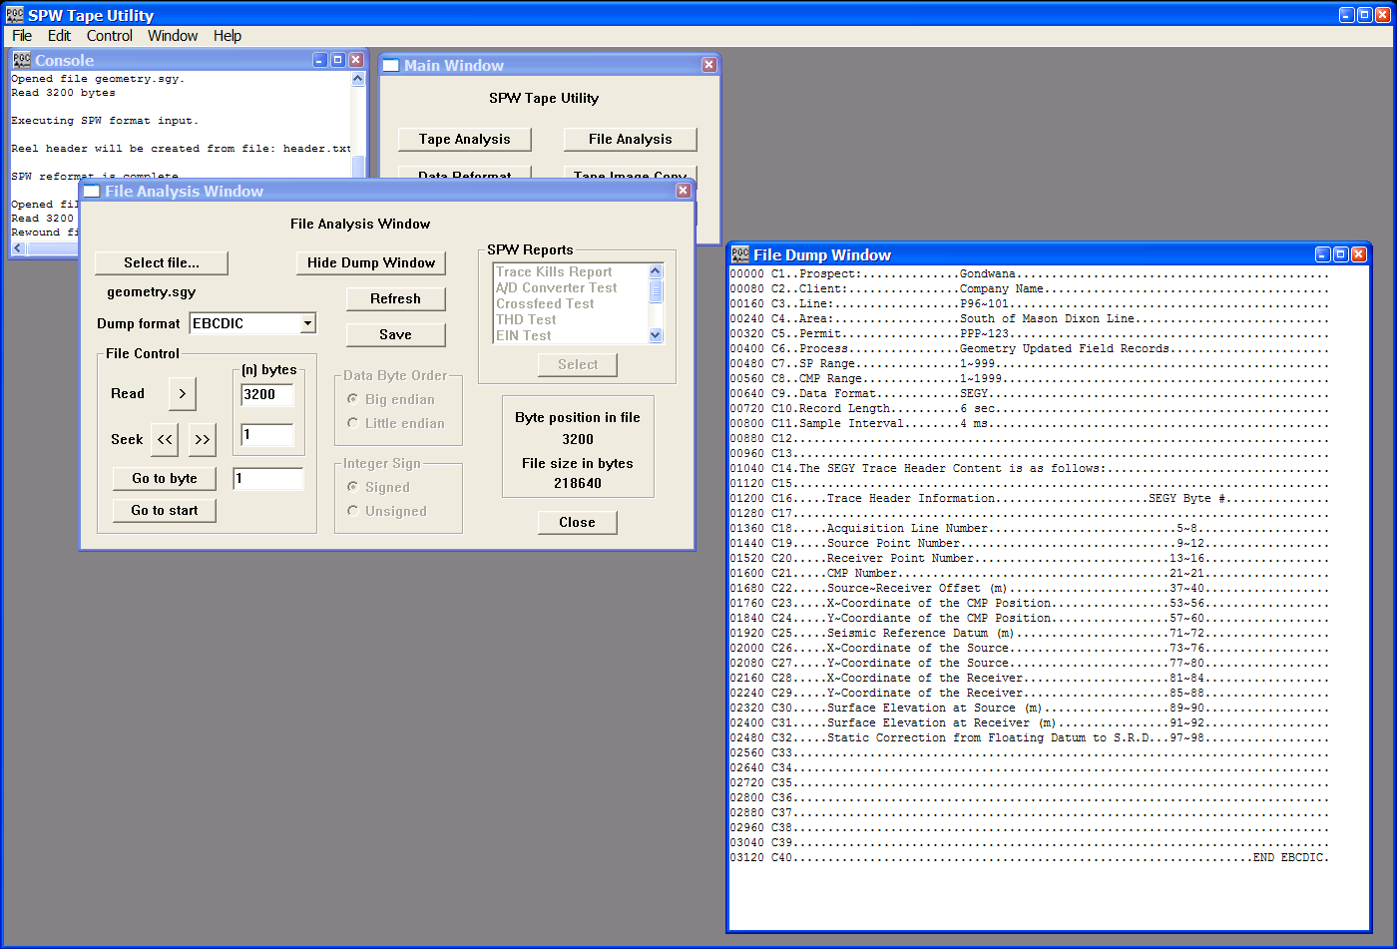
To dump the first 3200-bytes of data, click on the READ > button in the File Control submenu. The dump window will appear with the contents of the EBCDIC header.
The EBCDIC text header displayed in the File Dump Window.

The SEG-Y EBCDIC reel header contains 40 lines of comment cards, at 80-bytes per line. These comment cards are used to describe the contents of the SEG-Y file. After dumping the EBCDIC text header to the File Dump Window, the File Analysis utility is positioned at byte 3200 of the selected SEG-Y file, which is the correct position to read the 400-byte binary reel header. To read the binary reel header, set the dump format to Short Integer, the Data Byte Order to Big Endian, the Integer Sign to Unsigned, and instruct the File Analysis utility to read the next 400-bytes by entering this value in the parameter field to the right of the Read button in the File Control submenu. Click on the READ > button in the File Control submenu to dump binary reel header.

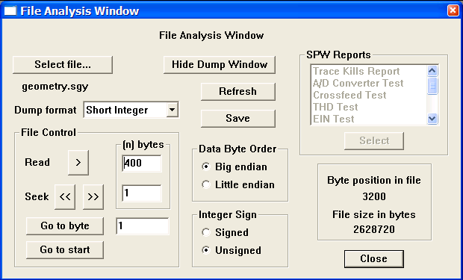
Preparing to read a SEG-Y binary reel header.

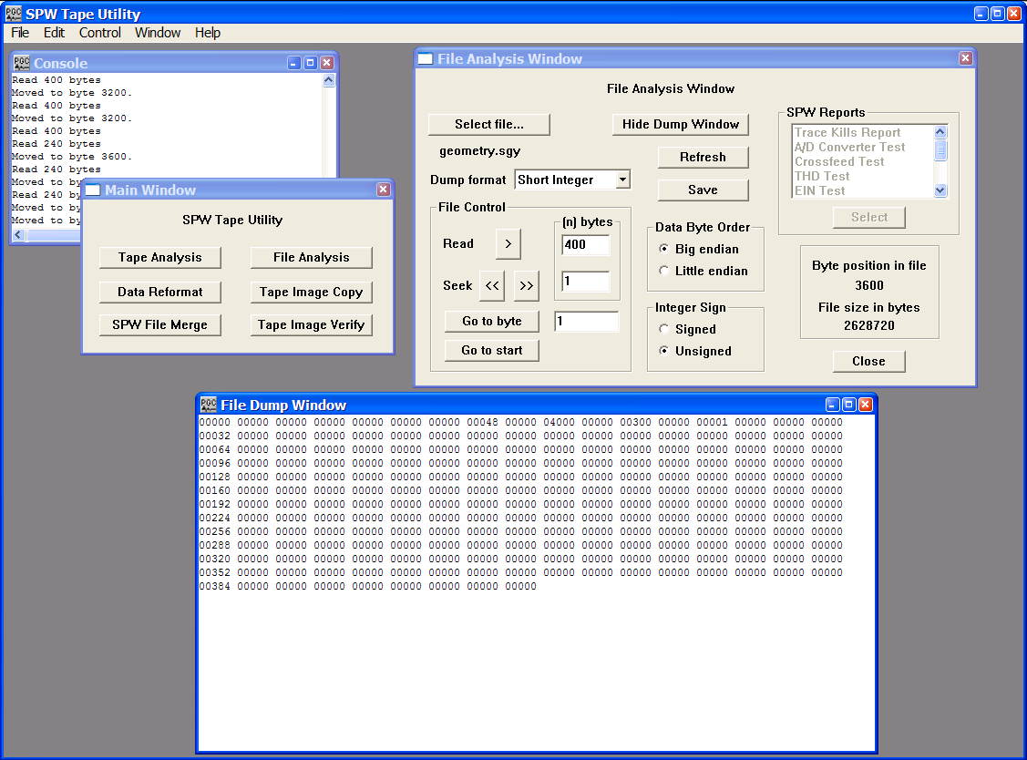The Binary reel header displayed in the File Dump Window.

The first 60-bytes of the SEG-Y binary reel header are assigned values that are described in the SEG-Y standard. The remaining 340-bytes are left unassigned and may contain any information that the processor deems necessary. The binary reel header displayed in the File Dump window in the figure above contains the bare minimum of information regarding the seismic file: (1) bytes 13-14 (bytes 3213-3214 in the file) indicate the number of data traces per record, in this case 48; (2) bytes 17-18 (bytes 3217-3218 in the file) indicate the sample rate in microseconds, in this case 4000; (3) bytes 21-22 (bytes 3221-3222 in the file) indicate the number of samples per data trace, in this case 300; and (4) bytes 25-26 (bytes 3225-3226 in the file) indicate the data sample format code, in this case 1 (1 = 4-byte floating point).

After dumping the binary reel header to the File Dump Window, the File Analysis utility is positioned at byte 3600 of the selected SEG-Y file, which is the correct position to read the 240-byte binary trace header corresponding to the first trace in the file. To read the binary trace header, set the dump format to Short Integer, the Data Byte Order to Big Endian, the Integer Sign to Signed, and instruct the File Analysis utility to read the next 240-bytes by entering that value in the parameter field to the right of the Read button in the File Control submenu. Click on the READ > button in the File Control submenu to dump binary trace header.
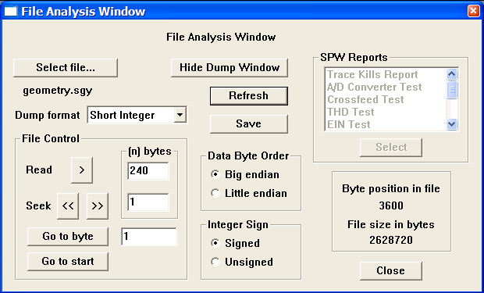

Preparing to read a SEG-Y binary trace header.

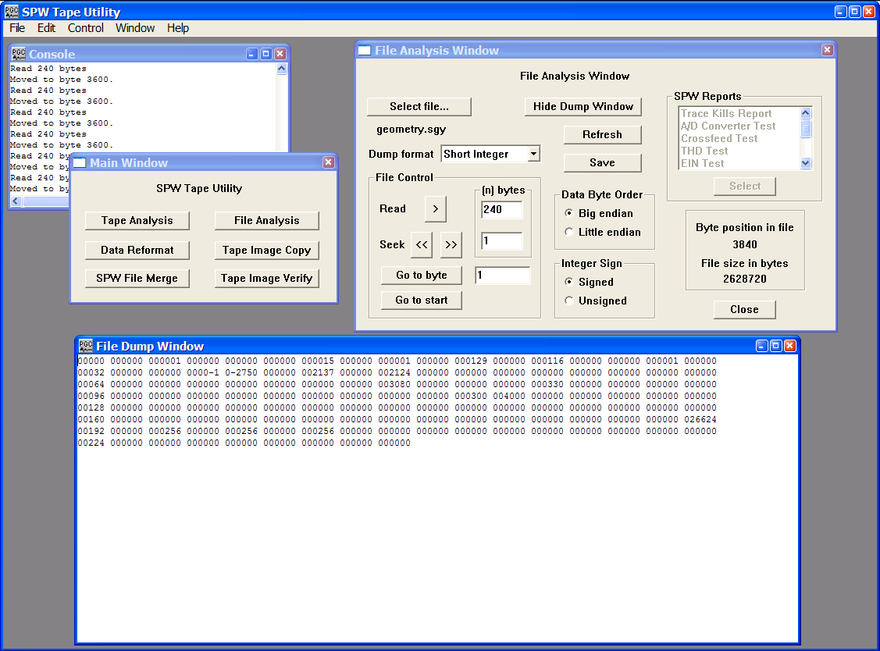
The Binary trace header displayed in the File Dump Window.

All 240-bytes of the SEG-Y binary trace header are assigned values that are described in the SEG-Y standard. The binary trace header displayed in the File Dump window in the figure above contains the trace information specific to the first data trace in the seismic file: (1) bytes 1-4 (bytes 3601-3604 in the file) indicate the trace sequence number in the line, in this case 1; (2) bytes 9-12 (bytes 3609-3612 in the file) indicate the field record number, in this case 15; (3) bytes 17-20 (bytes 3617-3620 in the file) indicate the source point number, in this case 129; (4) bytes 21-24 (bytes 3621-3624 in the file) indicate the CMP number of the data trace, in this case 116; (5) bytes 29-30 (bytes 3629-3630 in the file) indicate the trace identification code, in this case 1 (1 = seismic); (6) bytes 37-40 (bytes 3637-3640 in the file) indicate the source-receiver offset, in this case -2730; (7) bytes 41-44 (bytes 3641-3644 in the file) indicate the receiver group elevation, in this case 2137; (8) bytes 45-48 (bytes 3645-3648 in the file) indicate the surface elevation at the source, in this case 2124. A complete description of the SEGY standard is available from the Society of Exploration Geophysicists.

After dumping the binary trace header to the File Dump Window, the File Analysis utility is positioned at byte 3840 of the selected SEG-Y file, which is the starting position of the first trace data block. Each trace data block consists of 300 4-byte floating-point data samples, for a total of 1200-bytes. To read the trace data block, set the dump format to IEEE Float, the Data Byte Order to Big Endian, and instruct the File Analysis utility to read the next 1200-bytes by entering this value in the parameter field to the right of the Read button in the File Control submenu. Click on the READ > button in the File Control submenu to dump the trace data block.
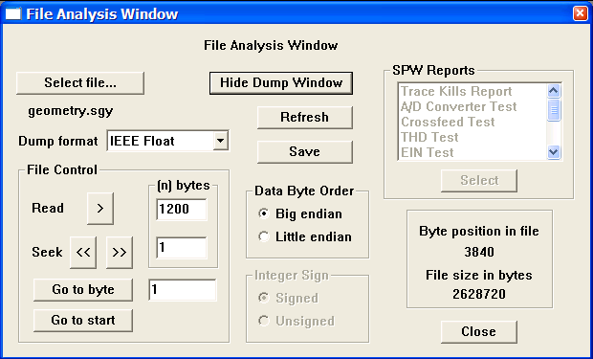
Preparing to read a SEG-Y trace data block.
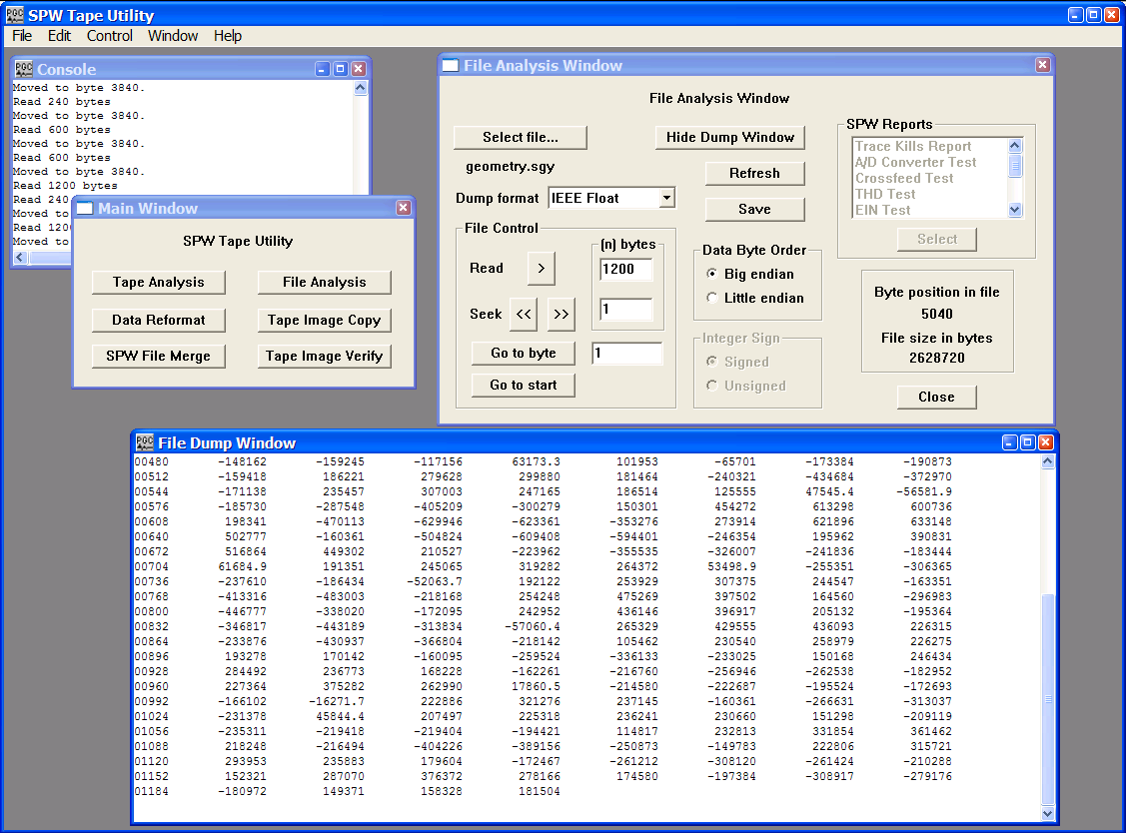
The trace data block corresponding to trace 1 of the data file displayed in the File Dump Window.

After dumping the first trace data block to the File Dump Window, the File Analysis utility is positioned at byte 5040 of the selected SEG-Y file, which is the starting position of the second binary trace header. To read the second binary trace header, set the dump format to Short Integer Float, the Data Byte Order to Big Endian, the Integer Sign to Signed, and instruct the File Analysis utility to read the next 240-bytes by entering this value in the parameter field to the right of the Read button in the File Control submenu. Click on the READ > button in the File Control submenu to dump the second binary trace header.
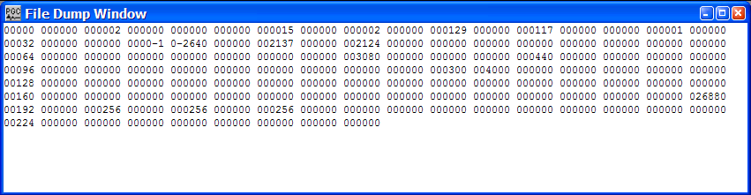
The second binary trace header, corresponding to trace 2, of source point 115. The source-receiver offset is –2640 and the CMP location is 117.

Example: SEG-D Format

The SEG-D format is really a family of seismic data acquisition formats that may be used to record both multiplexed and demultiplexed data. The original SEG-D tape standard was published in 1975 (Geophysics, 40, no. 02, 344-352) and has been revised twice to keep up with changes in the seismic data acquisition environment (Geophysics, 59, no. 04, 668-684; Geophysics, 62, no. 03, 1004-1031).

A basic SEG-D demultiplexed file format (fig. 2) consists of one or several 32-byte General Header blocks followed by one or several 32-byte Channel Set Descriptor blocks. The General Header blocks contain information specific to the seismic data in the file and the acquisition hardware used to acquire that data. An important aspect of the SEG-D family of formats is that SEG-D is self defining in the sense that information contained in the first General Header block specifies both the number of subsequent General Header blocks as well as the length of the data record. A Channel Set Descriptor block contains information specific to a single channel set, which is defined as a group of channels operating with identical recording parameters. The General Header and Channel Set Descriptor blocks are followed by the Channel sets, which consist of a number of 20-byte trace headers with their associated trace data samples. The trace headers contain basic information, such as file number and channel number, which are specific to their associated seismic trace. There is one trace header per seismic data trace. For more information concerning the SEG-D Format standards, consult the SEG digital tape standards at:

http://seg.org/publications/tech-stand/

To analyze a SEG-D file, use the Select file… button in the File Analysis window to open the Open Input Disk File dialog. The Open Input Disk File dialog is used to maneuver through the directory structure and select a SEG-D data file for analysis. After the desired SEG-D file has been selected, click on the Open button in the lower right corner of the Open Input Disk File dialog. Once the SEG-D file is selected, the File Analysis window will display: (1) the name of the file directly beneath the Select file… button; (2) the size of the file, in bytes, in the lower right corner; (3) and the byte position in the file at which the File Analysis utility is currently pointed.

Figure 2. Schematic representation of a SEG-D data file.
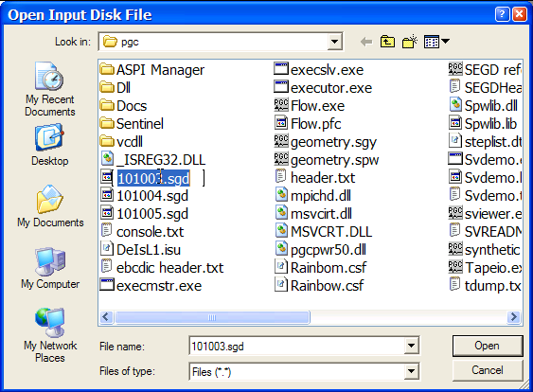
Open Input Disk file Dialog
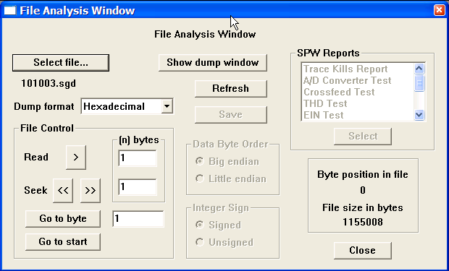
SEG-D file selected for analysis. Byte position in the file and the file size, in bytes, are displayed in lower right corner.

The SEG-D general header blocks contain information specific to their associated seismic data file, such as the file number, the SEG-D format code, the time of shooting, the sampling interval, and the record length. As stated above, a SEG-D demultiplexed file consists of one or several 32-byte General Header blocks followed by one or several 32-byte Channel Set Descriptor blocks. The original SEG-D format had one general header block followed by one or several Channel Set Descriptor blocks. SEG-D revisions 1 and 2 contain a minimum of two general header blocks and allow for additional general header blocks should the need arise. The number of additional general header blocks is indicated in General Header block #1.

All values in the general header blocks are written as packed binary coded decimal, unless otherwise specified. To read the general header, set the dump format to Hexadecimal using the drop down menu, and instruct the File Analysis utility to read the first 32-bytes by entering this value in the parameter field to the right of the Read button in the File Control submenu.

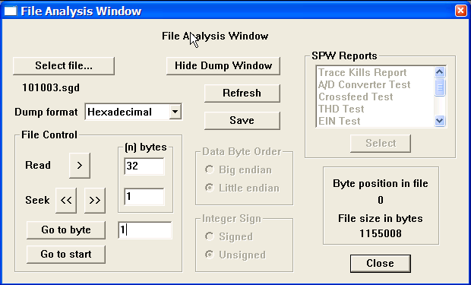
Preparing to read a SEG-D general header block.

To dump the currently selected 32-bytes of data, click on the READ > button in the File Control submenu. The dump window will appear with the contents of the first 32-byte general header.

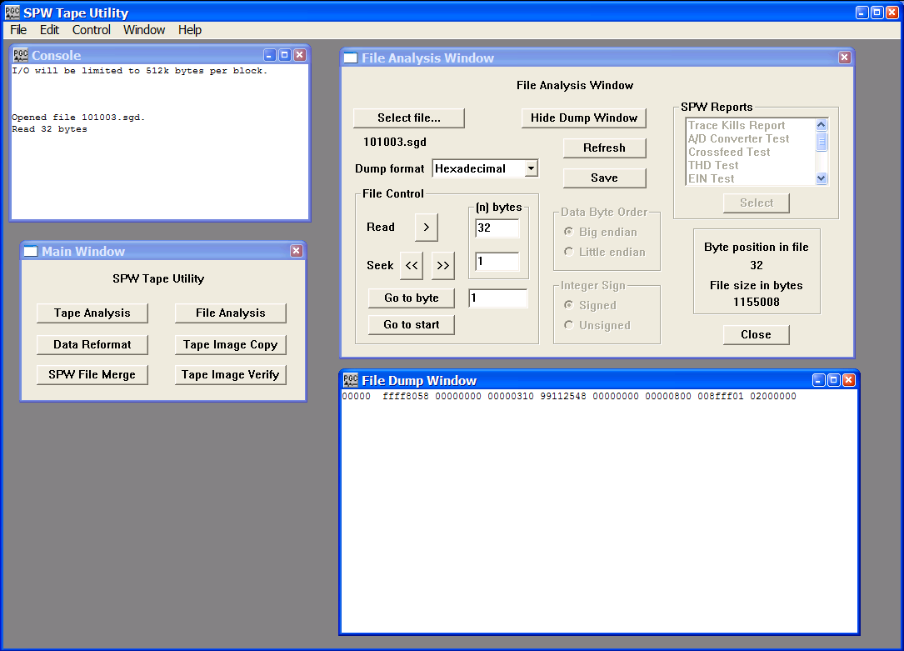
The first general header block displayed in the File Dump Window.

Each of the eight-character strings in the dump represents 4-bytes of the file. Eight strings equal 32-bytes. The SEG-D format code, 8058, in bytes 3-4, indicates that this file was written in one of the revised SEG-D formats (i. e. revision 1 or 2). SEG-D 8058 was not supported in the original SEG-D format description. In SEG-D 8058 data samples are written to file as 32-bit IEEE demultiplexed floating point values. The ‘ffff’ in bytes 1-2 indicates that the file number is greater than 9999 and is written in bytes 1-3 of general header block #2. The last two digits of the year (03), the Julian day (99), the hour (11), the minute (25), and the second (48) at the time of recording are contained in byte 11, byte 12 bits 5-8 and byte 13, byte 14, byte 15, and byte 16, respectively. The number of additional general header blocks (1) is contained in the first four bits of byte 12. This means that there are two general header blocks in total. The sample interval (0.5 ms) is coded as a binary number in byte 23. The ‘fff’ in byte 26 bits 5-8 and byte 27 indicates that the record length has been written in bytes 15-17 of general header block #2. The scan types per record (1) and number of channel sets per scan type (2) are contained in byte 28 and byte 29, respectively. Bytes 30, 31, and 32 indicate that there are no skew blocks, extended header blocks, or external header blocks. In summary, general header block #1 reveals that there are a total of two general header blocks and two channel set descriptor blocks prior to the first 20-byte trace header block. Therefore, the complete file header along with the first trace header can be dumped with 148 bytes (32 bytes + 32 bytes + 32 bytes +32 bytes + 20 bytes = 148 bytes), and the first data sample should be found at byte 149.

To dump the complete file header and the first trace header, reposition the File Analysis utility at the start of the file by clicking on the Go to Start button in the lower-left corner of the File Analysis window. This will cause the Byte Position in File indicator to return to ‘0’. Set the dump format to Hexadecimal using the drop down menu, and instruct the File Analysis utility to read the first 148-bytes by entering this value in the parameter field to the right of the Read button in the File Control submenu. Click on the READ > button to display the contents of the complete file header and the first trace header.

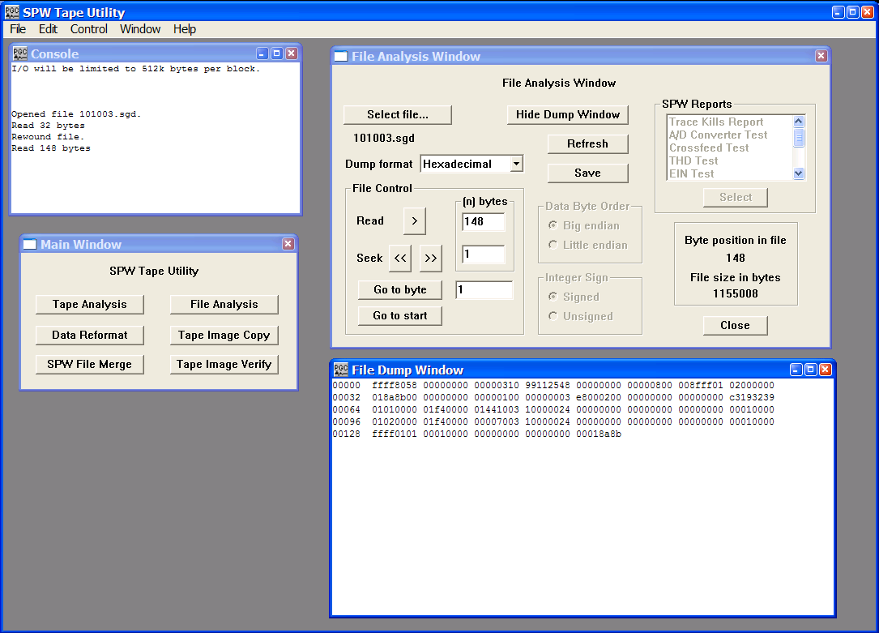
General header blocks 1 and 2, channel set descriptor blocks 1 and 2, and the first trace header displayed in the File Dump Window.

The first 32 bytes of the dump are the contents of the first general header block. The next 32 bytes are the contents of the second general header block, which contain the field file number (101003) as a hexadecimal value in bytes 1-3, the SEG-D revision number (1) in byte 11, and the record length (1000 ms) as a hexadecimal value in bytes 15-17. Bytes 20-32 are not defined in revision 1 of the SEG-D format. The fourth and fifth lines in the File Dump Window display the contents of the two Channel Set Descriptor blocks. In each case the scan number is in bytes 1-2 and the channel set is in bytes 3-4. The number of channels in the channel set is contained in bytes 9-10. Channel set one consists of 144 channels and channel set two is empty. The channel type indicator is in the first 4 bits of byte 11. Channel set one consists of seismic channels (1), and channel set two consists of channels described as “other” (7). The frequency of the anti-alias filter in Hertz and the roll-off of the filter in dB/octave are contained in bytes 13-14 and bytes 15-16, respectively. In each case, the frequency of the anti-alias filter is 1000 Hz and the roll-off is 24 dB/octave. The value of 1 in byte 30 of the channel set descriptor blocks indicates that the traces are unstacked. The final 20 bytes are the contents of the first trace header, which contains the scan number (1) in byte 3, the channel set (1) in byte 4, the trace number (1) in bytes 5-6, and the field file number (101003) in bytes 18-20.

The File Analysis utility is currently positioned at byte 148 of the selected SEG-D file. The trace data in each seismic file was sampled at 0.5 ms intervals with a record length of 1000 ms. Therefore, each seismic trace consists of 2000 32-bit (4 bytes) samples. To read the first 8 data samples in the first trace of the first file, set the dump format to IEEE Float, the Data Byte Order to Big Endian, and instruct the File Analysis utility to read the next 32-bytes by entering this value in the parameter field to the right of the Read button in the File Control submenu. Click on the READ > button in the File Control submenu to dump the trace data samples.

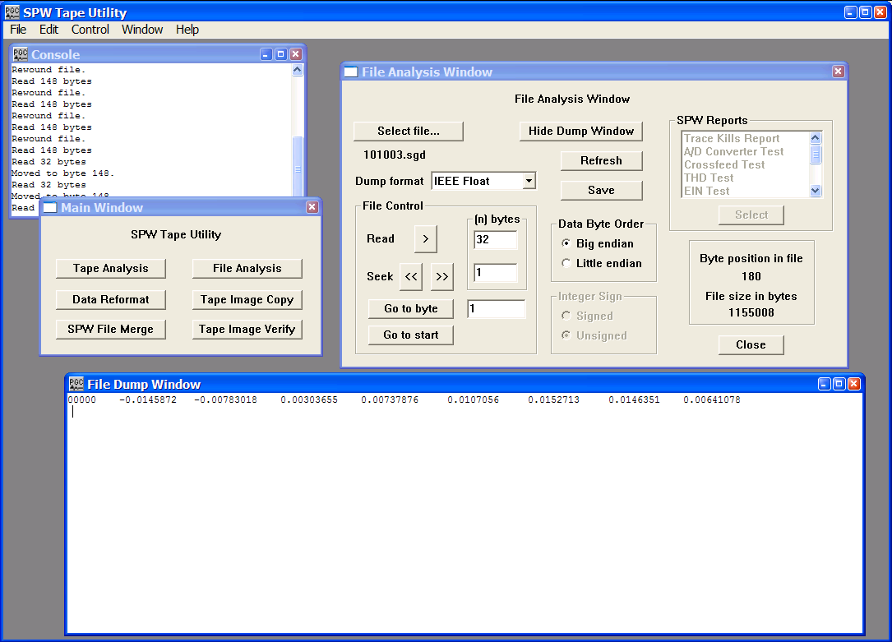
The first 8 data samples from trace 1 of the first file.

To read the second trace header file we need to skip forward to the end of the first traces data samples. The end of the first trace data is located at byte 8148 (64 bytes General Header + 64 Bytes Channel Set Descriptor + 20 bytes 1st Trace Header + 8000 bytes of the first data trace = 8148 bytes). To go to byte 8148 enter this value in the parameter box to the right of the Go to Byte button and the click on the button. Set the dump format to Hexadecimal, and instruct the File Analysis utility to read the next 20-bytes by entering this value in the parameter field to the right of the Read button in the File Control submenu. Click on the READ > button in the File Control submenu to dump the second trace header.

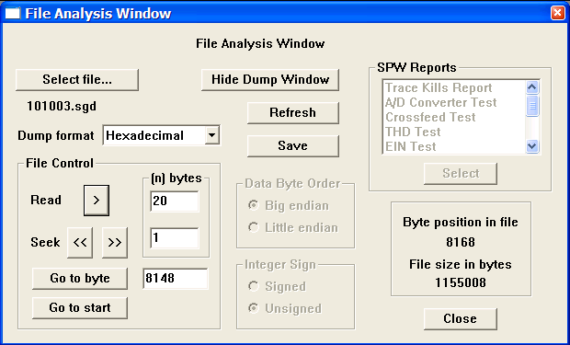
Preparing to read the second trace header.

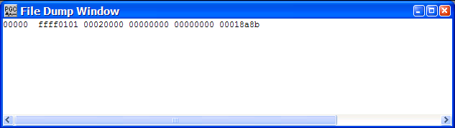
The contents of the second trace header.

As expected, the second trace header indicates that it is trace 2 of file 101003.

Example: SEG-2 Format

The SEG-2 format is data file format for raw and processed shallow seismic or digital radar data in the small computer environment. The original SEG-2 tape standard was published in 1990 (Geophysics, 55, no. 09, 1260-1271). An important point to keep in mind when analyzing SEG-2 files is that the byte count of a SEG-2 file starts at 0, as opposed to 1 for such files as SEG-Y and SEG-D.

A basic SEG-2 file structure (fig. 3) consists of a File Descriptor block, one or more Trace Descriptor Blocks, and one or more Data Blocks. A File Descriptor block consists of a 32-byte block of information concerning the structure of the data file and two variable length subblocks: A Trace Pointer subblock and a String subblock. The Trace Pointer subblock consists of a set of pointers to the beginning of each Trace Descriptor Block. All pointers are 32-bit unsigned long integers. The String subblock consists of a free format section of ASCII coded file descriptors such as acquisition data, acquisition time, sample interval, and number of samples per scan.

Trace Descriptor Blocks and Data Blocks follow the File Descriptor block at a rate of one per data trace. There is a one-to-one relationship between Trace Descriptor Blocks and Data Blocks. A Trace Descriptor Block consists of a 32-byte block of information concerning the structure of the subsequent data trace and a variable length String subblock describing the acquisition and processing history of the trace. The Data Block consists of data samples whose size and format are specified in the preceding Trace Descriptor Block. For more information concerning the SEG-2 Format standard, consult the SEG digital tape standards at:

http://seg.org/publications/tech-stand/

To analyze a SEG-2 file, use the Select file… button in the File Analysis window to open the Open Input Disk File dialog. The Open Input Disk File dialog is used to maneuver through the directory structure and select a SEG-2 data file for analysis. After the desired SEG-2 file has been selected, click on the Open button in the lower right corner of the Open Input Disk File dialog. Once the SEG-2 file is selected, the File Analysis window will display: (1) the name of the file directly beneath the Select file… button; (2) the size of the file, in bytes, in the lower right corner; (3) and the byte position in the file at which the File Analysis utility is currently pointed.

Figure 3. Schematic representation of a SEG-2 data file.
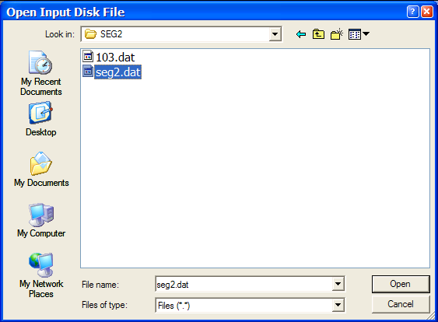Open Input Disk file Dialog

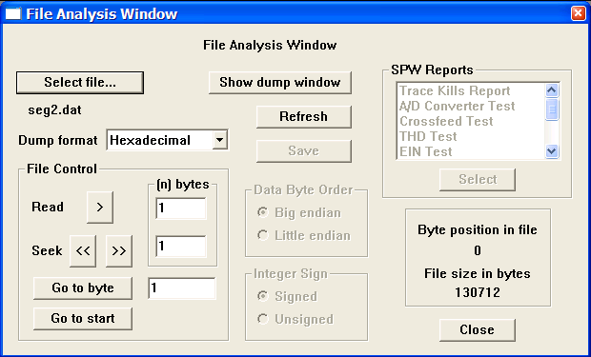
SEG-2 file selected for analysis. Byte position in the file and the file size, in bytes, are displayed in lower right corner.

The first two bytes of a SEG-2 file will always contain the Hexadecimal value 3a55. The value 3a55 serves three purposes: (1) it identifies the file as a SEG-2 file; (3) it indicates that these are the first two bytes of a File Descriptor Block; and (3) it indicates whether the file was written with a big-endian or a little-endian byte ordering. If bytes 0,1 are decoded as 3a55, then the file was written in big-endian byte order, in which the most significant values are assigned to the lowest byte address. In this case, all subsequent integer values should be dumped with the Data Byte Order set to big endian. If bytes 0,1 are decoded as 553a, then the file was written in little-endian byte order, in which the least significant values are assigned to the lowest byte address. In this case all subsequent integer values should be dumped with the Data Byte Order set to little endian.

To determine the byte ordering of the selected file, set the dump format to Hexadecimal using the drop down menu, and instruct the File Analysis utility to read the first 2-bytes by entering this value in the parameter field to the right of the Read button in the File Control submenu.
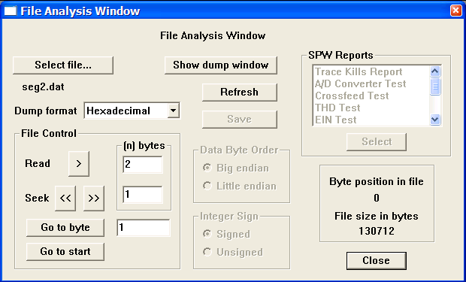
Preparing to determine the byte ordering of a SEG-2 data file.

To dump the first 2-bytes of data, click on the READ > button in the File Control submenu. The dump window will appear with the contents of the first 2-bytes of the SEG-2 file.
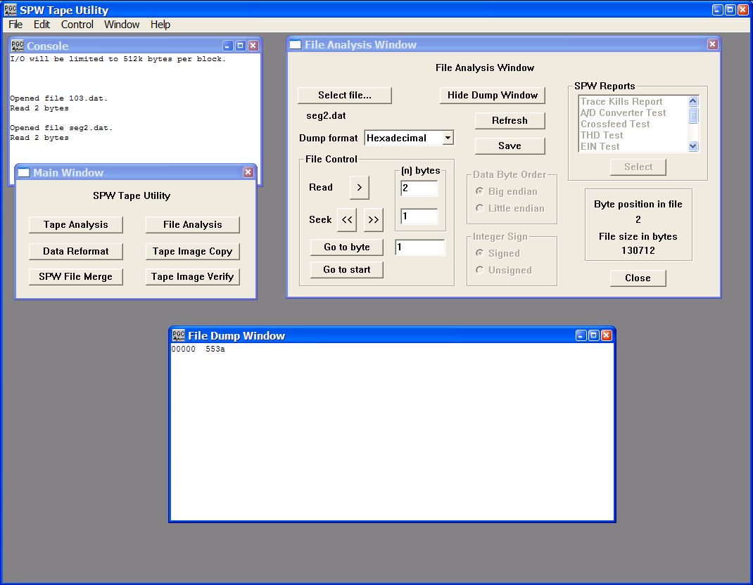
The first two bytes of the selected file, 553a, indicate that it was written with little-endian byte order.

The next two bytes of the File Descriptor block contain the SEG-2 revision number. The original SEG-2 standard has yet to be revised, so this number will always be 1. Bytes 4 and 5 of the File Descriptor block are coded as unsigned integers and contain the size of the Trace Pointer subblock in bytes. After reading the first two bytes of the file, the File Analysis utility is positioned at byte 2. To position the File Analysis utility at byte 4, you can either enter the value 4 in the Go to Byte parameter field and click on the Go to Byte button, or advance the File analysis utility 2 bytes by clicking twice on the Seek forward arrow. In either case, the result should be that the File Analysis utility indicates that the current byte position in the file is byte 4.

To determine the size of the Trace Pointer subblock in bytes, set the dump format to Short Integer using the drop down menu, the Data Byte Order to Little endian, the Integer Sign to Unsigned and instruct the File Analysis utility to read 2-bytes by entering this value in the parameter field to the right of the Read button in the File Control submenu. Click on the READ > button in the File Control submenu to display byte 4 and byte 5 of the SEG-2 file.

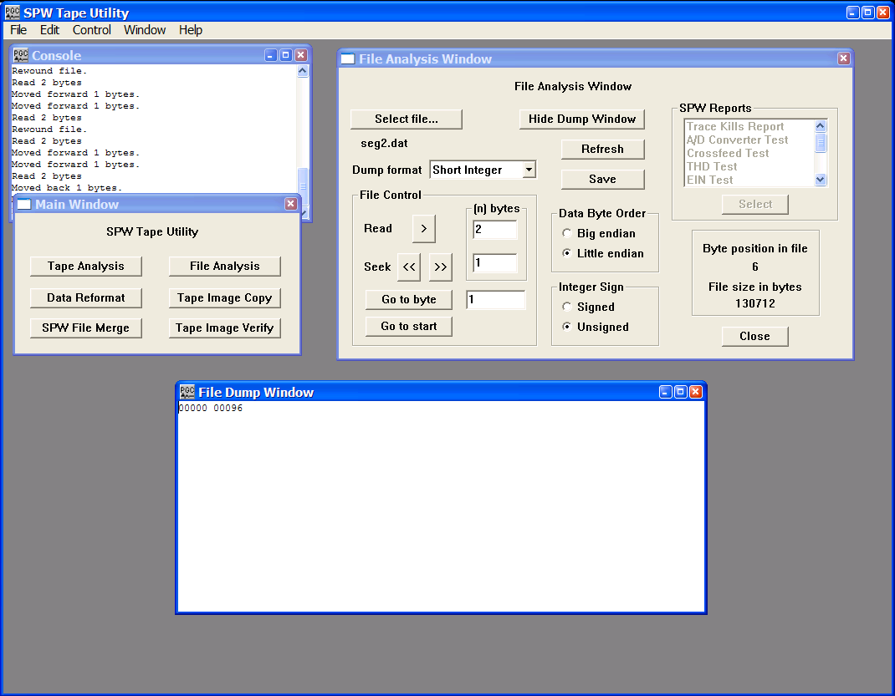
Bytes 4 and 5 of the selected file indicate that the size of the Trace Pointer subblock is 96 bytes.

The size of this particular Trace Pointer subblock is 96 bytes. Since each trace pointer is, by definition, 4 bytes (32-bits) long, the Trace Pointer subblock contains pointers to 24 data traces. Bytes 6 and 7 are coded as unsigned integers and indicate the number of traces actually in the file. To read this value, simply dump two more bytes in the current dump format.
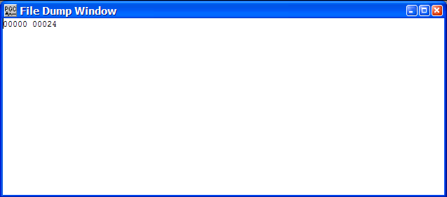
A dump of bytes 6 and 7 of the File descriptor block indicates that the file contains 24 data traces.

At this point we have established the byte ordering of the SEG-2 file and that current file contains 24 data traces. Therefore, the Trace Pointer subblock will begin at byte 32, extend to byte 127 (31 bytes File Descriptor + 96 bytes Trace Pointer subblock), and the first byte of the String subblock will begin at byte 128. A parameter of particular interest in the String subblock is the sampling interval. Each string in the String subblock begins with a 16-bit binary coded integer that represents the offset in bytes to the next string. The 16-bit integer is followed by an ASCII coded keyword that describes the string. The string ends with a 2-byte end-of-string terminator. The content of a String subblock is best displayed through example, so position the File Analysis utility at byte 128 and dump 2-bytes (16-bits) of unsigned Short Integer format.
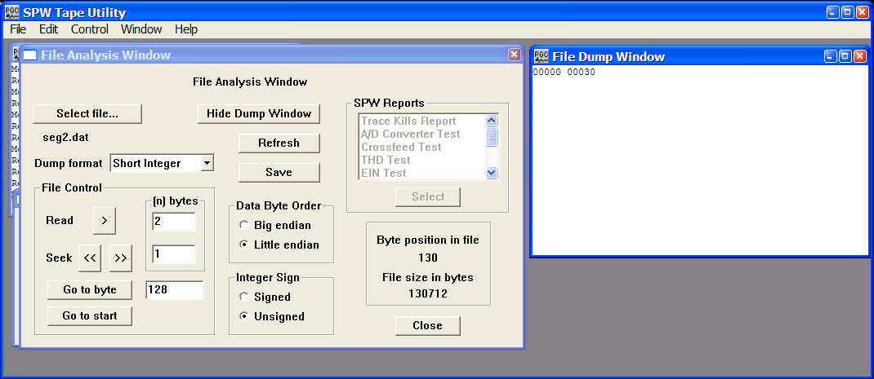
A dump of the first two bytes of the String subblock (bytes 128 and 129) indicates that offset from the beginning of the first string to the beginning of the second string is 30 bytes.

The dump indicates that there are 30 bytes from the beginning of the first string to the beginning of the second string. At present the File Analysis utility is positioned at byte 130, which is 2 bytes into the first string. To read the remainder of the string, set the dump format to ASCII and dump 28 bytes of data.
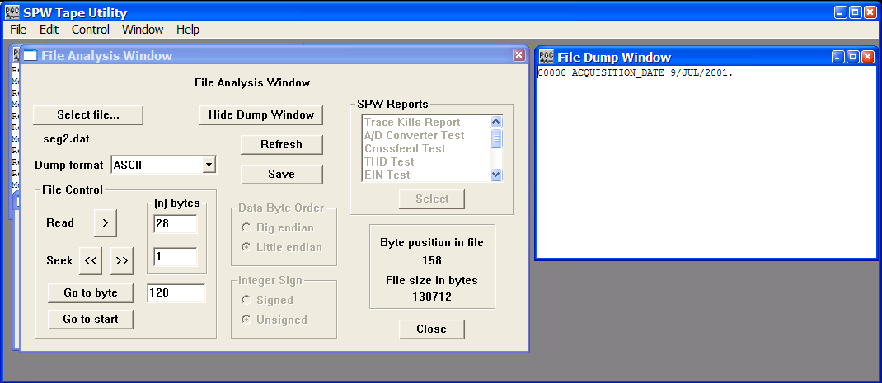
The contents of the first string in the String subblock.

To read the next string, first dump 2-bytes of unsigned short integer to find the string length, and then dump the string length less two (in bytes) as ASCII to read the contents of the string. To dump the value corresponding to the SAMPLE INTERVAL, you can proceed in this manner, string by string, or return to the first byte of the String subblock (byte 128) and dump a few hundred bytes of ASCII. In both cases, the purpose is to locate the sample interval.
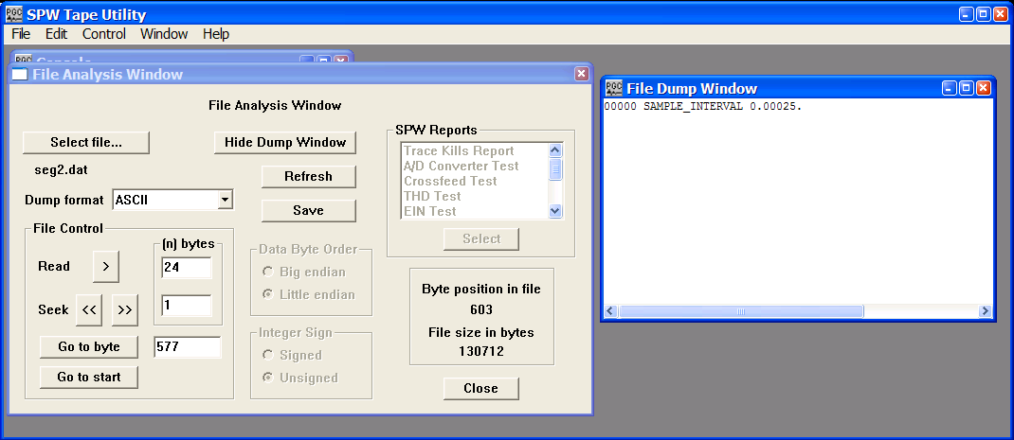
The sample interval of the data file.

Now we have established the byte ordering of the SEG-2 file (little endian), the number of data traces in a SEG-2 file (24), and the sample rate (0.25ms). All that remains is to determine the number of samples per trace to reformat the data to the SPW internal format.

The number of samples in a SEG-2 Data Block is contained in the corresponding Trace Descriptor block. The byte location of each Trace Descriptor block is referenced by a pointer in the Trace Pointer subblock. The Trace Pointer subblock started at byte 32 and allocated 4 bytes for each of the 24 trace pointers. Therefore, the trace pointer for the 12th trace will be contained in bytes 76-79. Dump these bytes as Unsigned Long Integers to determine the starting location of the Trace Descriptor block corresponding to Trace 12.

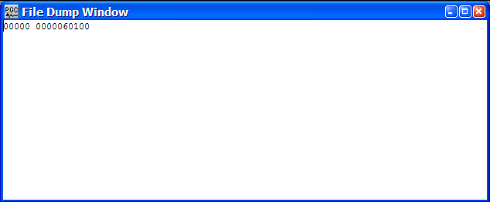
A dump to determine the starting location of the Trace Descriptor block corresponding to Trace 12. The starting byte is 60100.

The number of samples in a SEG-2 Data Block is coded as unsigned long integer in bytes 10 and 11 of the Trace Descriptor block. So, the first step is to advance the File analysis utility to the start of any of the 24 Trace Descriptor blocks. For trace 12 this is byte 60100. To insure that the File Analysis utility is correctly positioned at the beginning of the Trace Descriptor block, a hexadecimal dump of the next 2 bytes (e.g. 60100-60101) of the file should produce the value 2244 (4422 in the case of big-endian byte ordering). This is the SEG-2 format identifier for a Trace Descriptor block.

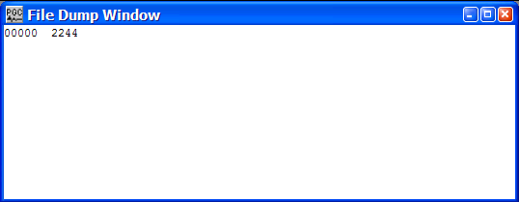
The first two bytes of a Trace Descriptor block contain the hexadecimal identifier 2244.

Bytes 2 and 3 of the Trace Descriptor block are coded as unsigned integer and contain the size of the block in bytes. Bytes 4-7 of the Trace Descriptor block are coded as unsigned long integer and contain the size of the data block in bytes. Finally, bytes 8-11 of the Trace Descriptor block are coded as unsigned long integer and contain the number of samples in the subsequent data block in bytes. To read this value, advance the File Analysis utility to byte 60108 and dump 4 bytes of unsigned long integer.

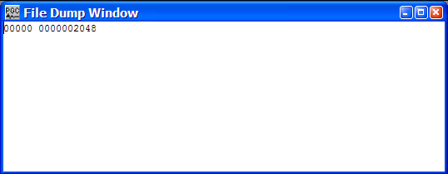
Bytes 8-11 of a Trace Descriptor block contain the number of samples in the Data Block coded as unsigned long integer..

At this point the file analysis has provided you with everything you need to properly reformat the SEG-2 files to SPW format: (1) the byte ordering; (2) the number of data traces; (3) the sample rate; (4) the number of samples per trace. Trace length is equal to the number of samples per trace times the sample rate.

Data Reformat

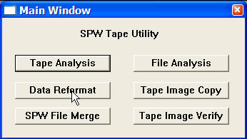
The Data Reformat utility is designed to efficiently reformat tape and disk files from foreign seismic and radar formats to SPW format, from foreign formats to SEG-Y format, and from SPW format to SEG-Y format. To use the Data Reformat utility, simply click on the Data Reformat button in the Main Window and the Reformat window will appear.
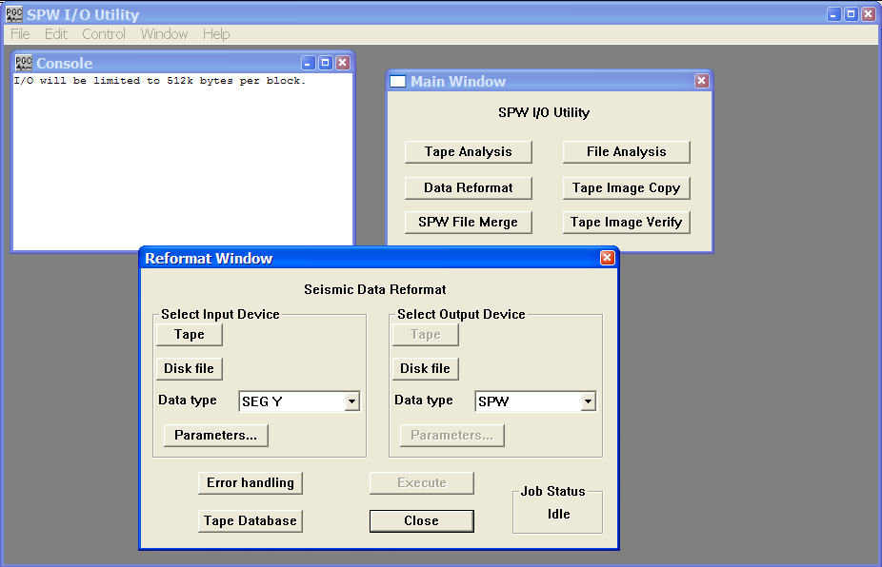
Main Window

Reformat Window

The remainder of the chapter will: (1) discuss the various features of the Reformat window; (2) explain the various formats that the Data Reformat utility is capable of reformatting; (3) provide examples in which actual SEG-Y, SEG-D, and SEG-2 data files are reformatted to SPW format; (4) and detail the steps required to correctly reformat a SPW file to a SEG-Y formatted file.

Reformat Window
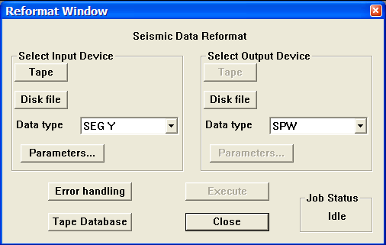

The Reformat Window.

Parameter Dialog

Select Input Device – Select the input file location and format.

Tape – Used to select input files that are on an external tape drive.

Disk File – Used to select input files that are on a disk file.

Data type – Used to set the input data format.

Parameters – Used to set or change specific input data format parameters.

Select Output Device – Select the output file location and format.

Tape – Used to select output files that will be on an external tape drive.

Disk File – Used to select output files that will be on a disk file.

Data type – Used to set the output data format.

Parameters – Used to set or change specific output data format parameters.

Error handling – Opens the Error Handling dialog, which provides an option for stopping data reformat from an external tape drive if there are tape media errors.

Execute – Used to execute a reformat job once the input and output parameters have been fully specified.

Close – Close the Reformat window.

Tape Database – Used to access to the Tape/File Database. Once open, the user may enter foreign tape (i.e. SEGD) names or numbers and information regarding the contents of the tapes into the file database.

Job Status – Lists the status of any reformat activity. Prior to the execution of a reformat job, the Job Status is “Idle”. When reformatting, the Job Status is “Running”. If the reformat was executed successfully, the Job Status is “Complete”. If the reformat was not executed successfully, the Job Status is “Failed”.

Format Types

The Data Reformat utility is designed to reformat files from foreign seismic and radar formats to SPW format, from foreign formats to SEG-Y format, and from SPW format to SEG-Y format. The foreign seismic and radar formats currently handled by the IO Utility Reformat utility include:

ABEM – ABEM Terraloc Mk3, Mk4, Mk5, and Mk6 seismograph formats.

Bison 2 – Bison seismograph format.

EG&G – EG&G Geometrics seismograph format.

GSSI – Geophysical Survey Systems Inc. ground penetrating radar format.

MALA – Mala Geoscience ground penetrating radar format.

OYO – Oyo Instruments DAS seismograph format

Reftek – Reftek seismic format for Texan recorders.

SEG-2 – Raw and processed shallow seismic or digital radar data format.

SEG-A – Seismic data acquisition format for binary gain, 2-byte recording systems.

SEG-B – Seismic data acquisition format for binary gain, 2-byte recording systems.

SEG-C – Seismic data acquisition format for true floating-point recording systems.

SEG-D – Industry standard seismic data acquisition format.

SEG-Y – Seismic data exchange format.

SENSORS – Sensors and Software ground penetrating radar format.

SCINTREX – Scintrex seismic data format.

SPW – Parallel Geoscience Corp. internal format.

Example: Reformat from SEG-Y Format

The SEG-Y format is primarily used as a data exchange format. The original SEG-Y tape standard was published in 1975 (Geophysics, 40, no. 02, 344-352) and was revised once in 2002 to keep up with changes in the seismic data acquisition. For a complete description of the SEG-Y Format standard, consult the SEG digital tape standards at:

http://seg.org/publications/tech-stand/

To reformat a SEGY file from disk, set the input Data type to SEGY with the appropriate drop down menu, and use the input Disk file button to open the Open Input Disk File dialog. The Open Input Disk File dialog is used to maneuver through the directory structure and select a SEG-Y data file for reformat. Next, set the output Data type to SPW with the appropriate drop down menu, and use the output Disk file button to open the Save dataset as dialog. The Save dataset as dialog is used to maneuver through the directory structure and set/create a SPW file for output from the reformat.

By default, the Reformat utility is designed to reformat SEG-Y using a trace header structure defined by the SEG-Y standard. This standard is defined in a read-only format file (tusegy.tfm) that comes as part of the SPW software installation. If your data conforms to the standard, all that you need to do to reformat the SEG-Y file to SPW format is click Execute. The SEG-Y EBCDIC header will be displayed in the Console window, and if the reformat is executed successfully, the Job Status will indicate ‘Complete’.
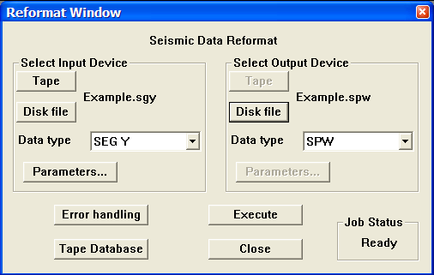
Select the SEG Y input file and the SPW output file.
If your SEG-Y data contains non-standard trace header information that is required to successfully reformat the data, or that you would liked to be mapped into the SPW trace header, additional format instructions are necessary. To access the SEG Y Input format definitions, click on the Parameters… button in the Reformat window. Starting from the top of the SEG Y Input Format dialog are the following subwindows:
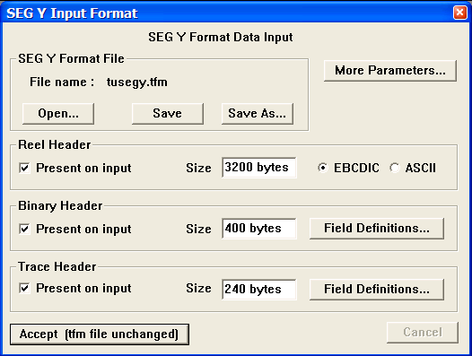
Click on the Parameters… button in the Reformat window to access the SEG Y Input Format parameter dialog.

SEGY Format File – This subwindow indicates the format file that will be used to describe the structure of the SEG-Y reel header and trace headers during data reformat. If any changes are made to the Reel Header, the Binary Header, or the Trace Header definitions, those definitions can be saved for future use by clicking on the Save button and creating a new file.

Reel Header – The standard SEG-Y reel header consists of a 3200-byte EBCDIC text header and a 400-byte binary header. By default both are present.

Binary Header – The standard SEG-Y reel header consists of a 3200-byte EBCDIC text header and a 400-byte binary header. By default both are present. To edit or review the binary header field definitions, click on the Field Definitions… button. The header fields displayed in the SEGY Binary Header Fields Definition dialog are the header field that the SEG Y standard strongly recommends be recorded in the binary header. To review the default description of any of the required header fields, select the field and then click on the Edit Field button. An Edit Binary Header Field dialog will display information particular to that header field.

For example, select Sample interval and click on Edit Field. The resulting Edit Binary Header Field dialog reveals that the sample interval, as defined by the SEG Y standard, is coded as a short integer in bytes 17-18 of the binary reel header. If the sample header has been coded differently in the SEG Y data you wish to reformat, update the Edit Binary Header Field dialog accordingly.
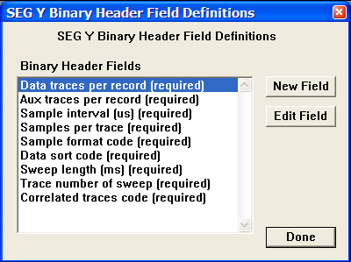
Click on the Field Definitions… button in the Binary Header submenu of the SEG Y Input Format window to access the SEG Y Binary Header Field Definitions dialog.

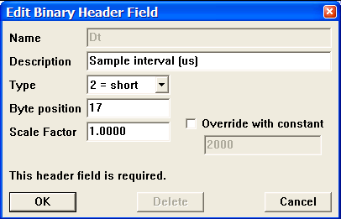
Click on the Edit Field button in the SEG Y Binary Header Field Definitions dialog to access the Edit Binary Header Field dialog.

Trace Header – A standard SEG-Y formatted file consists of a 240-byte of binary coded trace header appended to each traces data samples. To edit or review the trace header mapping from SEG Y to SPW, click on the Field Definitions… button. The header fields displayed in the SEGY to SPW Mapping List window are obtained by default, though the mapping will only be correct if the SEGY headers are in their standard prescribed locations. To review the default description of any of the SEG Y header fields, select that field in the SEG Y Trace Header window, and then click on Edit Field button. An Edit Trace Header Field dialog will display information particular to that header field.

For example, select CDP number in the SEG Y Trace Header window and click on Edit Field. The resulting Edit Trace Header Field dialog reveals that the CDP number, as defined by the SEG Y standard, is coded as a long integer in bytes 21-24 of the binary trace header. If the trace header has been coded differently in the SEG Y data you wish to reformat, update the Edit Trace Header Field dialog accordingly.

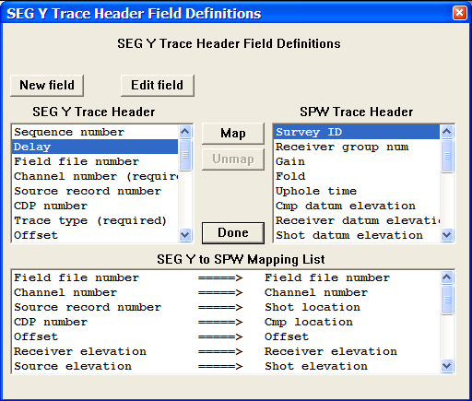
Click on the Field Definitions… button in the Trace Header submenu of the SEG Y Input Format window to access the SEG Y Trace Header Field Definitions dialog.
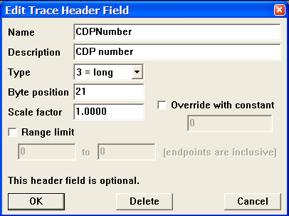
Click on the Edit Field button in the SEG Y Binary Header Field Definitions dialog to access the Edit Binary Header Field dialog.
More Parameters… – The More Parameters… button opens the SEG Y Input Options dialog. This dialog contains the following subwindows:
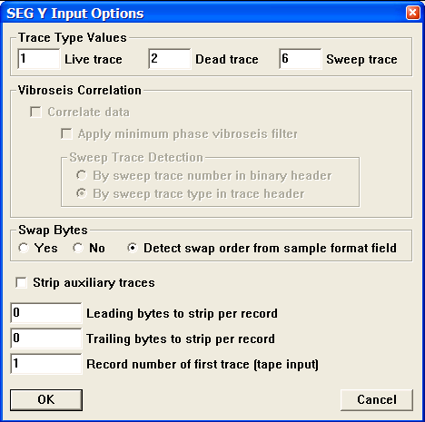
Click on the More Parameters… button in the SEG Y Input Format window to access the SEG Y Input Options dialog.

Trace Type Values – Bytes 29-30 of the binary trace header contain a trace identification code that is used to distinguish normal seismic traces from non-standard seismic traces such as sweeps, time breaks, upholes, etc. The SEG Y standard identifies a seismic trace as ‘1’, a dead trace as ‘2’, a dummy trace as ‘3’, a time break as ‘4’, an uphole trace as ‘5’, a sweep trace as ‘6’, a timing trace as ‘7’, and a water break trace as ‘8’.

Vibroseis Correlation – Not active.

Swap Bytes – By default, the Reformat utility will detect the byte order (big endian or little endian) of the data samples from the sample format field.

Strip auxiliary traces – If checked, the Reformat utility will strip any auxiliary traces from the input file prior to reformatting the data.

Example: Reformat from SEG-D Format

The SEG-D format is really a family of seismic data acquisition formats that may be used to record both multiplexed and demultiplexed data. The original SEG-D tape standard was published in 1975 (Geophysics, 40, no. 02, 344-352) and has been revised twice to keep up with changes in the seismic data acquisition environment (Geophysics, 59, no. 04, 668-684; Geophysics, 62, no. 03, 1004-1031). For a complete description of the SEG-D Format standard, consult the SEG digital tape standards at:

http://seg.org/publications/tech-stand/

To reformat a SEG-D file from disk, set the input Data type to SEGD with the appropriate drop down menu, and use the input Disk file button to open the Open Input Disk File dialog. The Open Input Disk File dialog is used to maneuver through the directory structure and select a SEG-D data file for reformat. Next, set the output Data type to SPW with the appropriate drop down menu, and use the output Disk file button to open the Save dataset as dialog. The Save dataset as dialog is used to maneuver through the directory structure and set/create a SPW file for output from the reformat.

By default, the Reformat utility is designed to reformat demultiplexed SEG-D data using information provided in the SEG-D header. As such, no user input is required for the majority of SEG-D data types. Simply click Execute, and if the reformat is executed successfully the Console window will display the SEG-D revision number, the SEG-D format code, the sample interval, the trace length, and the number of channels per record.

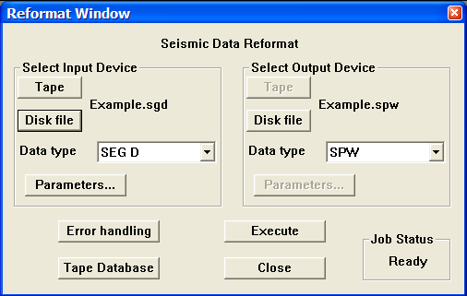

Select the SEG D input file and the SPW output file.

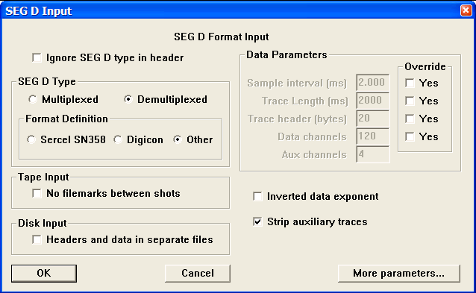

Click on the Parameters… button in the Reformat window to review the SEG D format input parameters.

Example: Reformat from SEG-2 Format

The SEG-2 format is data file format for raw and processed shallow seismic or digital radar data in the small computer environment. The original SEG-2 tape standard was published in 1990 (Geophysics, 55, no. 09, 1260-1271). For a complete description of the SEG-2 Format standard, consult the SEG digital tape standards at:

http://seg.org/publications/tech-stand/

To reformat a SEG-2 file from disk, set the input Data type to SEG 2 with the appropriate drop down menu, and use the input Disk file button to open the Open Input Disk File dialog. The Open Input Disk File dialog is used to maneuver through the directory structure and select a SEG-2 data file for reformat. Next, set the output Data type to SPW with the appropriate drop down menu, and use the output Disk file button to open the Save dataset as dialog. The Save dataset as dialog is used to maneuver through the directory structure and set/create a SPW file for output from the reformat.

By default, the Reformat utility does not automatically extract the necessary information from the SEG-2 trace header to reformat the data. The user must supply this information in the SEG 2 Input Format dialog by clicking on the Parameters button in the Select Input Device submenu. The required information consists of the trace length, the sample interval, and the number of channels. If this information was not provided with your SEG-2 dataset, your can still extract it from the SEG-2 header. Consult the section on SEG-2 data in the File Analysis chapter for more details.

Once the required information has been entered in the SEG 2 Input dialog, you may execute the reformat job. Simply click Execute, and if the reformat is executed successfully the Console window will display the number of SEG-2 files that were processed along with such record specific information as the record number, the source location of the record, and the receiver location of the first channel. The source and receiver location numbers will only be present if the recorder was properly programmed at the time of acquisition.

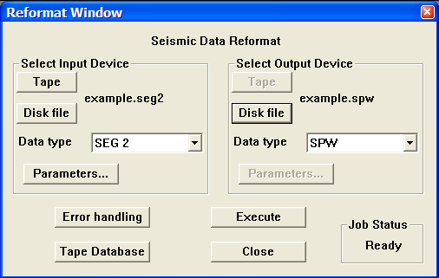
Select the SEG 2 input file and the SPW output file.

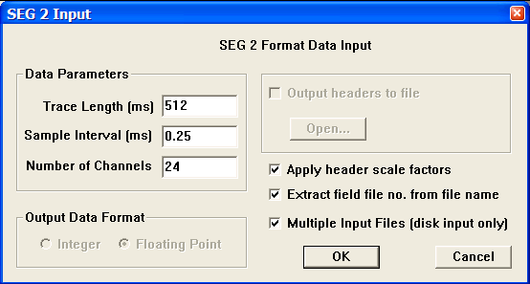
Click on the Parameters… button in the Reformat window to enter the trace length, the sample interval, and the number of channels in the SEG 2 Input dialog.

Outputting SPW files in SEG-Y format

The creation of standard SEG-Y files from SPW files is a straightforward task. By default, the Reformat utility is designed to map SPW trace header values to the corresponding SEG-Y trace header locations according to a read-only format file (tusegy.tfm) that comes as part of the SPW software installation. The default EBCDIC reel header is a blank 3200 byte block that contains no information. The default binary reel header is 400 bytes and the default binary trace header is 240 bytes. Both contain all of the information that has been described as mandatory in the SEG-Y standard. For a complete description of the SEG-Y Format standard, consult the SEG digital tape standards at:

http://seg.org/publications/tech-stand/

To output an SPW file as a SEGY file on disk, set the input Data type to SPW with the appropriate drop down menu, and use the input Disk file button to open the Open Input Disk File dialog. The Open Input Disk File dialog is used to maneuver through the directory structure and select the SPW data file that will be reformatted. Next, set the output Data type to SEG-Y with the appropriate drop down menu, and use the output Disk file button to open the Save dataset as dialog. The Save dataset as dialog is used to maneuver through the directory structure and set/create a SEG Y file for output from the reformat.
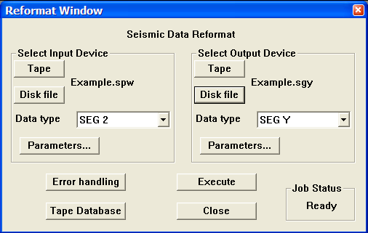
Select the SPW input file and the SEG Y output file.
If you would like to create an EBCDIC header or map additional information into either the SEG-Y binary reel header or the SEG-Y trace header, additional format instructions are necessary. To access the SEG Y Output format definitions, click on the Parameters… button in the Reformat window. Starting from the top of the SEG Y Output Format dialog are the following subwindows:
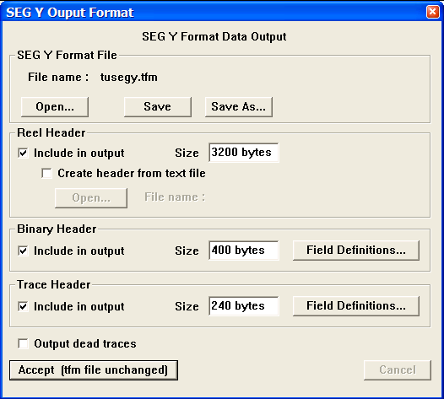
Click on the Parameters… button in the Reformat window to access the SEG Y Output Format parameter dialog.

SEGY Format File – This subwindow indicates the format file that will be used to describe the structure of the SEG-Y reel header and trace headers during data reformat. If any changes are made to the Reel Header, the Binary Header, or the Trace Header definitions, those definitions can be saved for future use by clicking on the Save button and creating a new file.

Reel Header – The standard SEG-Y reel header consists of a 3200-byte EBCDIC text header and a 400-byte binary header. Although by default both are present, the EBCDIC header remains blank unless updated by the user. The quickest way to create an EBCDIC header for your SEG-Y data file is through a simple Windows based text editor application such as Notepad. Simply open a blank document and create a file that contains 40 lines of eighty characters, keeping in mind that the return character represents a hidden character (or 1 byte). The raw document would look something like this:
Unedited EBCDIC Reel header.
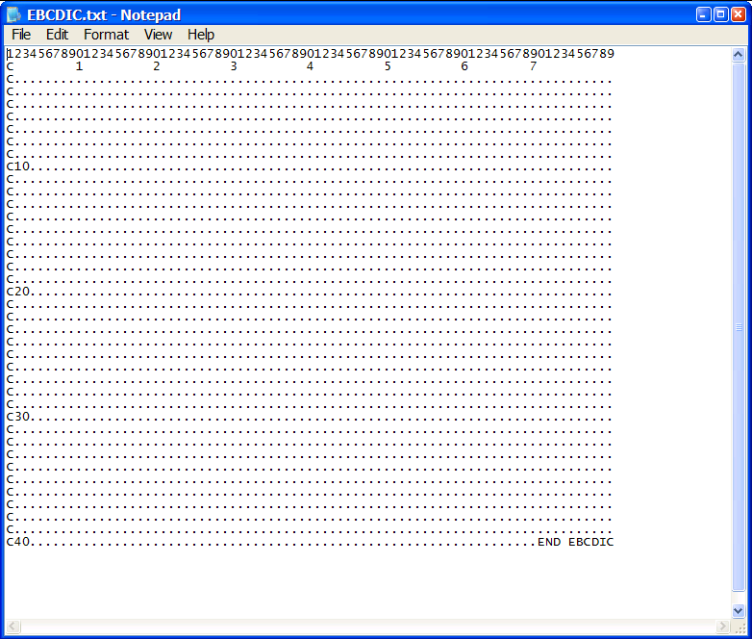

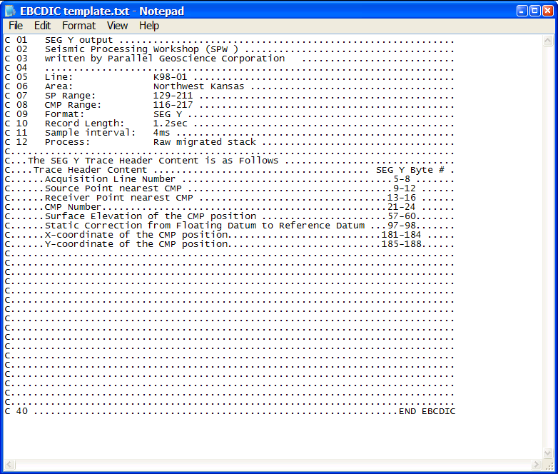
After updating the EBCDIC header, it may look something like this:
An example of an EBCDIC Reel header.

To insert the EBCDIC text header you have created into the reel header of the reformatted SEG-Y data file, first activate the Open… button by checking the Create header from text file box, then use the Open… button to select the text file.
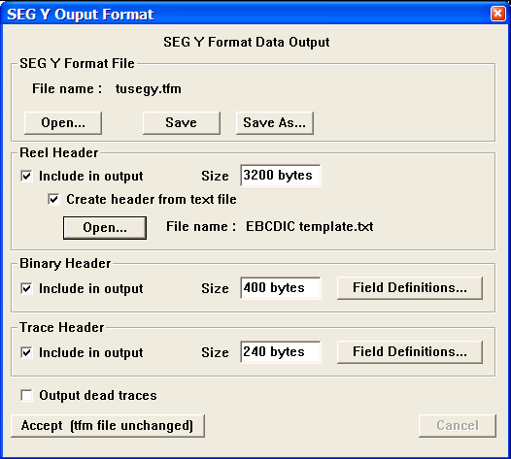
Select the text file used to construct the EBCDIC reel header.

Binary Header – The standard SEG-Y reel header consists of a 3200-byte EBCDIC text header and a 400-byte binary header. To edit or review the binary header field definitions, click on the Field Definitions… button. The header fields displayed in the SEGY Binary Header Fields Definition dialog are the header field that the SEG Y standard strongly recommends be recorded in the binary header. To review the default description of any of the required header fields, select the field and then click on the Edit Field button. An Edit Binary Header Field dialog will display information particular to that header field.

For example, select Sample interval and click on Edit Field. The resulting Edit Binary Header Field dialog reveals that the sample interval, as defined by the SEG Y standard, will be coded as a short integer in bytes 17-18 of the binary reel header.
Click on the Field Definitions… button in the Binary Header submenu of the SEG Y Input Format window to access the SEG Y Binary Header Field Definitions dialog.

Click on the Edit Field button in the SEG Y Binary Header Field Definitions dialog to access the Edit Binary Header Field dialog.

Trace Header – A standard SEG-Y formatted file consists of a 240-byte of binary coded trace header appended to each traces data samples. To edit or review the trace header mapping from SPW to SEG0-Y, click on the Field Definitions… button. The header fields displayed in the SPW to SEGY Mapping List window are obtained by default, though the mapping will only be meaningful if the SPW headers contain the listed information. To review the default description of any of the SEG Y header fields, select that field in the SEG Y Trace Header window, and then click on Edit Field button. An Edit Trace Header Field dialog will display information particular to that header field.

For example, select Cmp location => CDP number mapping in the SPW to SEG Y Mapping List window and click on Edit Field. The resulting Edit Trace Header Field dialog reveals that the CDP number, as defined by the SEG Y standard, will be coded as a long integer in bytes 21-24 of the binary trace header. If you would like the SEG Y trace header to be coded differently, update the Edit Trace Header Field dialog accordingly. However, keep in mind these are the byte locations where the CDP number is expected to reside.

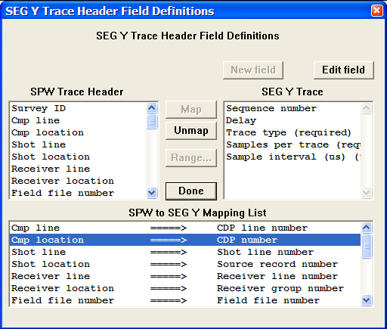
Click on the Field Definitions… button in the Trace Header submenu of the SEG Y Output Format window to access the SEG Y Trace Header Field Definitions dialog.
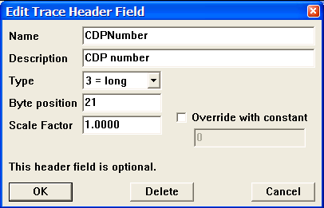
Click on the Edit Field button in the SEG Y Binary Header Field Definitions dialog to access the Edit Binary Header Field dialog.

Tape Database

The IO Utility Tape Database allows the user to enter foreign tape names or numbers and information regarding the contents of those tapes into the file database. The file database catalogues the basic information contained in each data file, such as the data file name, the project name, and the name of the processing flow that created the data file. Also registered in the database are the min-max range of trace header values in the data file, such as Field File number Shot Line number, Shot Location number, Receiver Line number, Receiver Location number, CMP Line number, and CMP Location number. Information regarding the name, number, and/or contents of physical tapes must be entered into this database by hand. Information regarding the contents of disk files created by SPW processing flows is automatically input to the database when a seismic file is created in a processing flow.
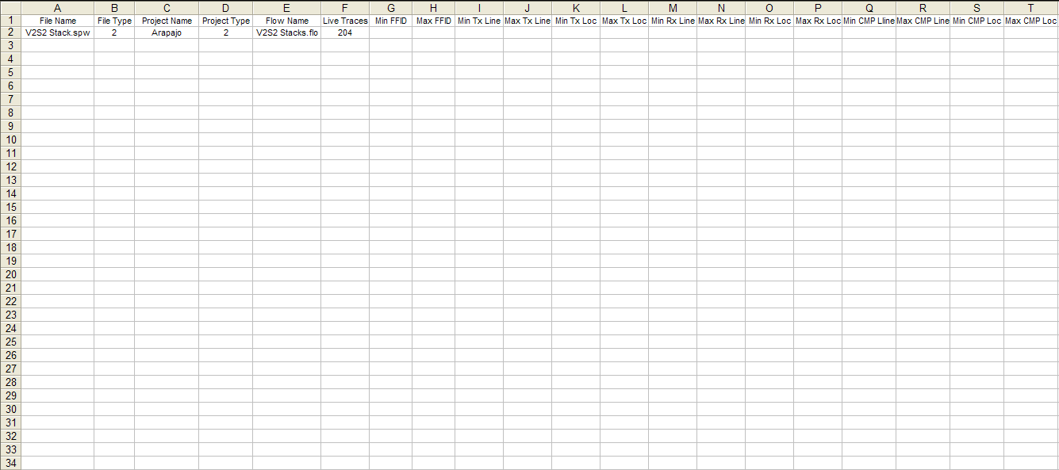

Tape Image Copy

The Tape Image Copy capability allows you to (1) copy files from any attached SCSI tape drive to another attached SCSI tape drive, (2) copy from a SCSI tape drive to a disk image file, and (3) copy from a disk image file to an attached SCSI tape drive. To use the Tape Image Copy utility, simply click on the Tape Image Copy button in the Main Window and the Copy window will appear.
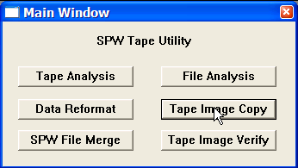
Main Window dialog
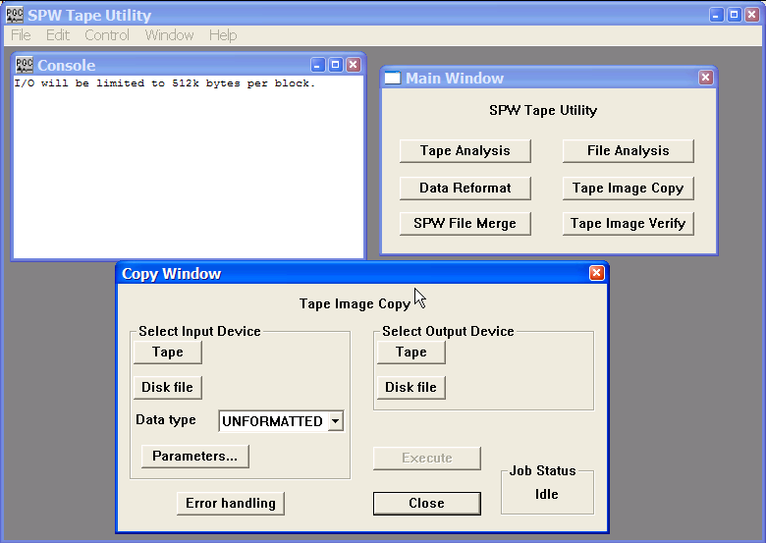
Copy Window dialog

The remainder of the chapter will: (1) discuss the various features of the Copy Window; (2) discuss the input and output formats that the Copy Window supports; and (3) provide examples of tape image copies of unformatted, SEG-Y, and SEG-D data from one tape to another.

Copy Window
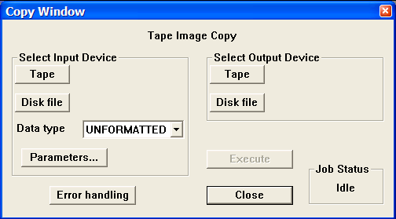
The Copy Window.

Parameter Dialog

Select Input Device – The Select Input device options are used to select the file to be copied, the format of the file, and the range of data in the file that will be copied to output.

Tape - The Tape button opens the Input Tape Select dialog, which is used to select attached SCSI tape drive containing a tape with data to be copied.
No rewind on close – The input tape will not be rewound at the end of the tape copy session.

Unload on EOT – Tape automatically unloads when the end of tape marker is found

Auto-loader – Indicates that an auto-loader will be used to load multiple input tapes.

M4 mode – Check M4 mode if an M4 tape drive is selected.
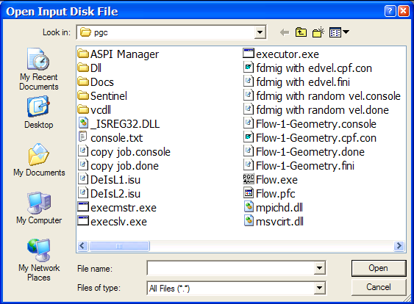
Disk - The Disk button opens the Open Input Disk File dialog, which is used to select a disk file that contains data to be copied.

Data type - The Data type drop down menu is used to select the format of the file to be copied. Available formats include Unformatted, SEG-Y, and SEG-D

Parameters - The Parameters button is used to specify copy parameters for the data type selected in the Data type drop down menu. The parameter dialog for each of these data type will be discussed at length in the sections below.

Select Output Device – The Select Output device options are used to select the output file that will contain the tape image copy.

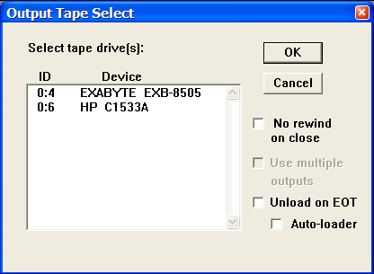
Tape - The Tape button opens the Output Tape Select dialog, which is used to select an attached SCSI tape drive that will contain the tape image copy.

No rewind on close – The output tape will not be rewound at the end of the tape copy session.

Use multiple outputs – In the case of a SEGD tape image copy, indicates that multiple output tapes will be used.

Unload on EOT – Tape automatically unloads when the end of tape marker is found

Auto-loader – Indicates that an auto-loader will be used to load multiple output tapes.

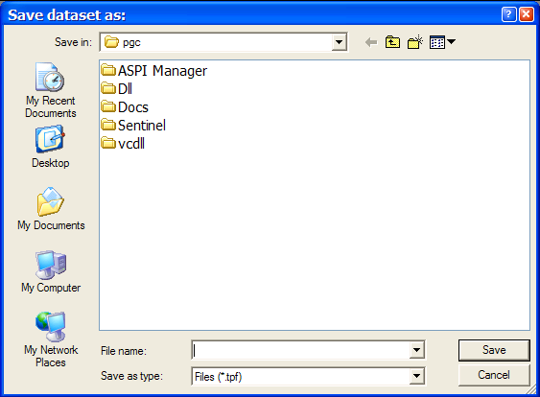
Disk - The Disk button opens the Save dataset as dialog, which is used to select a disk file that will contain the tape image copy.

Error Handling – The Error Handling button opens a dialog that allows the tape copy to stop in the case of input tape media errors.

Execute – The Execute button is used to initiate the tape copy.

Close – The Close button is used to exit the Copy Window at the end of a tape copy session.

Job Status – Lists the status of any tape copy activity. Prior to the execution of a tape copy job, the Job Status is “Idle”. When copying, the Job Status is “Running”. If the copy was executed successfully, the Job Status is “Complete”. If the copy was not executed successfully, the Job Status is “Failed”.

Input data types

The Tape Image copy utility is capable of copying Unformatted, SEG-Y or SEG-D formatted data files. Each of these formats has a corresponding Parameters dialog.
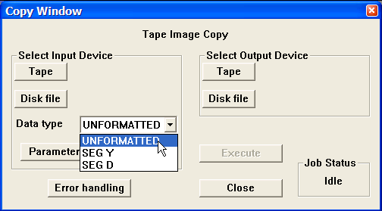
The drop down window of input formats.

Unformatted

The Unformatted copy is designed for bit-for-bit copy of data from an attached SCSI tape drive to disk. The parameter dialog for the Unformatted copy allows you to specify the type of the output file as well as the mode for reading the input tape. The .tpf file format is a SPW disk file format that contains special information about both the structures of the tape file as well as the data in the tape file. The .tpf file format allows you to input a tape, copy the data contained on that tape to disk, and then output the disk file to another tape with the exact information and blocking structure contained on the original tape. This is very useful in the field when you only have one tape drive. The .tim format is the stream data as it was read from tape.

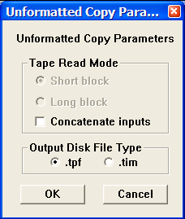
The Unformatted Copy Parameter dialog.

SEG Y

The SEG-Y copy is designed to read in SEG Y data from tape and copy it either to disk or to tape. The SEG Y Copy Parameters dialog allows the user to modify the standard copy operation by (1) range limiting the input dataset according to trace header values, and (2) sorting the output file by as many as three trace header values. Any header words in the SEG Y trace header may be specified as control points to range limit the input data or sort the output data. The control points may be entered manually or may be input from a file.

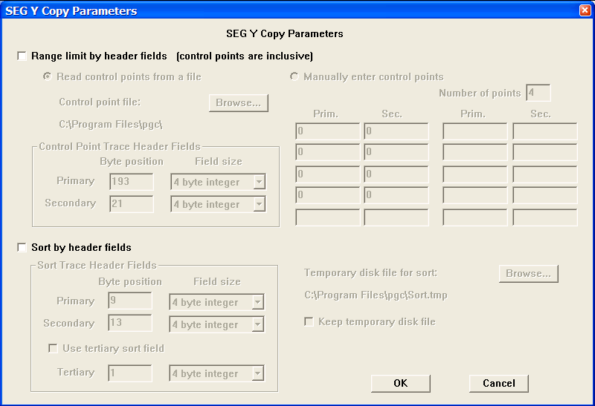
The SEG Y Copy Parameters dialog.

In order to properly use the range-limiting feature of SEG Y copy, it is important to understand how to define the range of input values. The region of data to be output from the copy is the set of traces that falls within the closed polygon described by the control points. Since the control points describe a closed polygon, it is essential that the ordered pairs of header values (from the primary and secondary header fields) be listed - either manually or in the input text file – in sequential order around the perimeter of the polygon being described.
For example, if you wanted to output all traces within a rectangle defined by the inline range 200-500 and the crossline range 100-400 (fig. 1), the set of ordered pairs used to describe the bounding rectangle would be:
200, 100
200, 400
500, 400
500, 100

Note that it is not necessary to 'close' the polygon explicitly. IO Utility will assume a closing boundary between the first control point and the last control point.

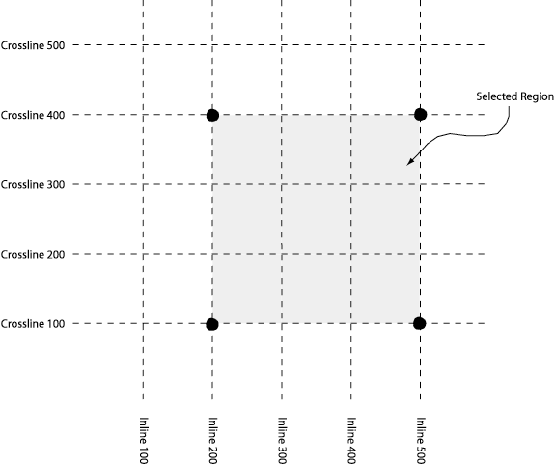
Figure 1. The output region defined by the ordered pairs (200,100), (200,400), (500,400), and (500,100).

To range limit the input, check the Range limit by header field box in the SEG Y Copy Parameters dialog. The any pair of trace header values may be used to range limit the output data and the ranges may be defined manually in the SEG Y Copy Parameters dialog or in a file accessed through the Browse button. By default, the primary and secondary trace header field used to range limit the data are the inline number (bytes 193-196 of a standard SEG Y trace header file) and the crossline number (bytes 21-24 of a standard SEG Y trace header file).
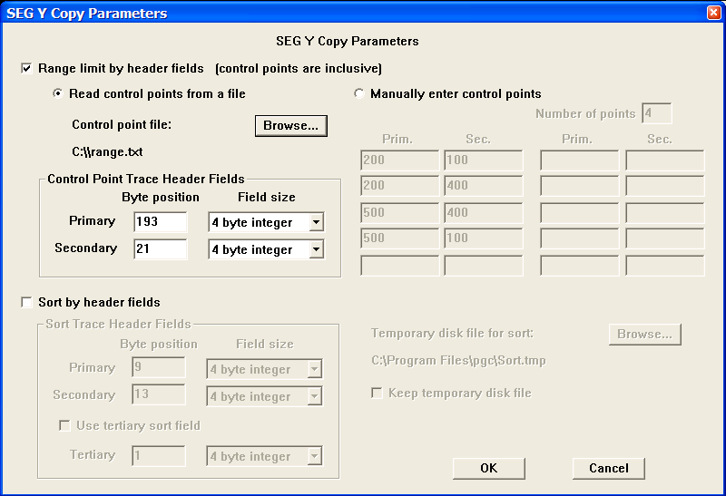
Read the control points from a file.

To range limit the input from a file that specifies the control points illustrated in figure 1, check <Read control points from a file>, and use the Browse button to read a simple text file with one inline (primary) - crossline (secondary) pair per line:

200, 100
200, 400
500, 400
500, 100

To manually range limit the input according to the control points illustrated in figure 1, check <Manually enter control points> and fill in the appropriate values:
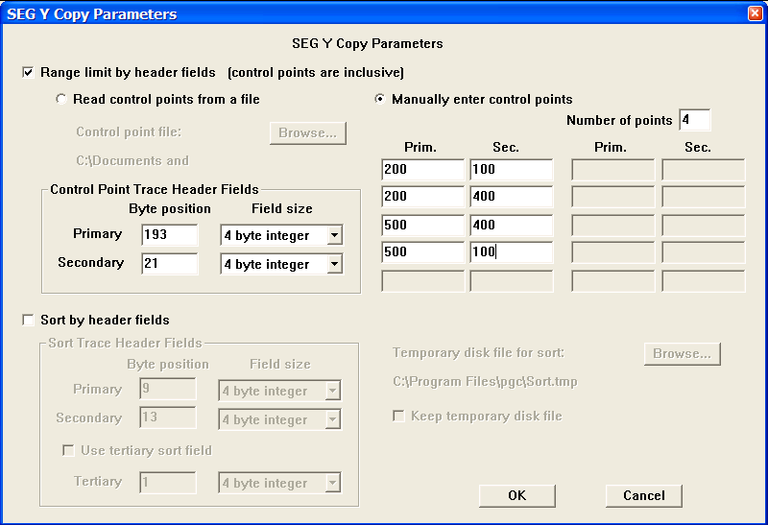
Manually enter the control points.

To sort the output according to trace header values, check the Sort by header fields box, and then set the byte positions in the SEG Y trace header that will control the sort order of the output file. By default, the output data are sorted according to field file number (bytes 9-12 of a standard SEG Y trace header file) and channel (bytes 13-16 of a standard SEG Y trace header file). A third trace header value may be used in the sort if needed.

SEG D

The SEG-D copy is designed to read in SEG D data from a disk file or an attached SCSI tape drive and write it to a SCSI tape drive. This option may be useful when the field data are written directly to disk in SEG-D format, as is the case with the Seistronix recording instrument. The SEG D Copy Parameters dialog allows you to specify a log file that will record the field files transferred during the copy operation.
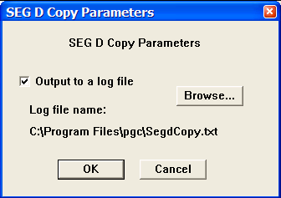
SEG D Copy Parameters Dialog.

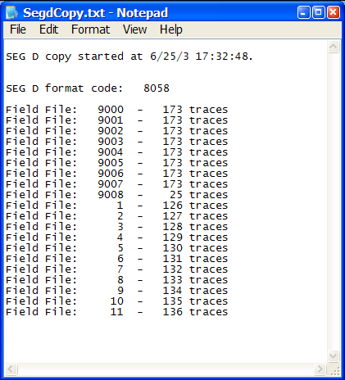

Example SEG D log file.

Creating Multiple Tape Copies

To create to multiple tape copies simultaneously, open the Output Tape Select dialog by clicking the Tape button under Select Output Device. Check the Use multiple outputs option in the Output Tape Select dialog and then select the desired devices through the combined use of the cursor and either the Shift or Ctrl key.
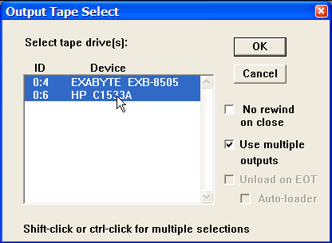
Output Tape Select Dialog

Input and Output from more than one tape

When you are reading from multiple tapes and you encounter an end of tape (EOT) marker on the input tape, you will be prompted with the Input Tape Continuation dialog which allows you to load a new input tape to the device and either continue or end the process.
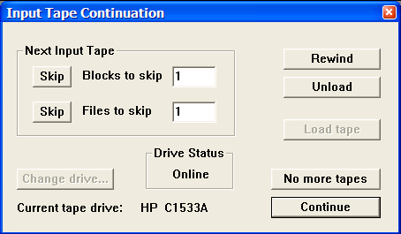
Input Tape Continuation Dialog

If the Tape Image Copy utility is being used to write multiple SEGD tapes and you encounter an end of tape (EOT) condition on one of the output tapes, you will be prompted with the Output Tape Continuation. The Output Tape Continuation dialog is similar to the Input Tape Continuation dialog in that it allows you to load a new output tape to the device and continue or to end the process.

SPW File Merge

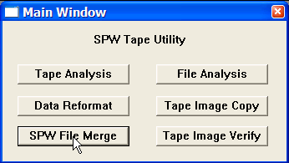
The SPW File Merge utility allows you to concatenate several SPW disk files into a single file. To use the SPW File Merge utility, simply click on the SPW File Merge button in the Main Window and the SPW File Merge window will appear.
Main Window

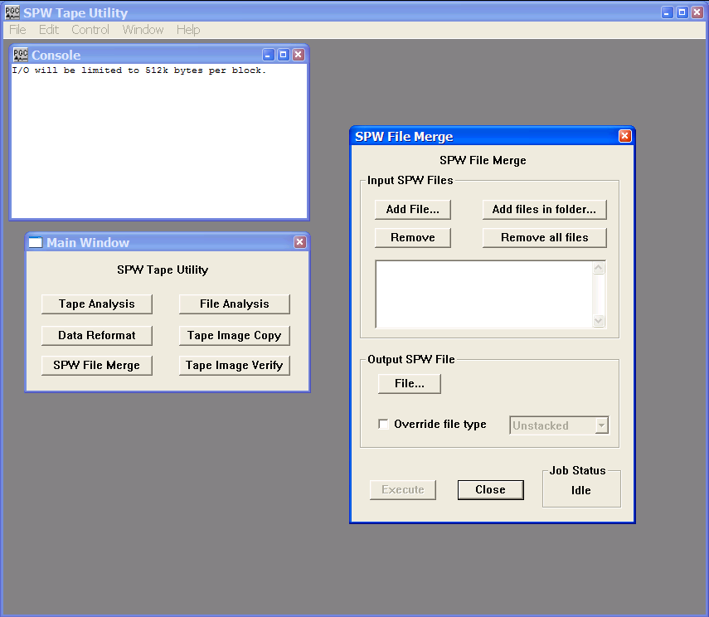
SPW File Merge Window

The remainder of the chapter will discuss the various features of the SPW File Merge window.

SPW File Merge Window

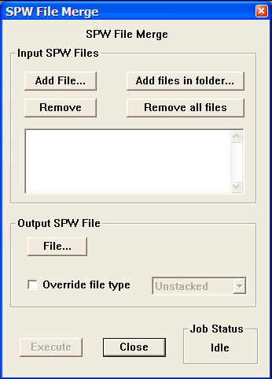
The SPW File Merge window.

Parameter Dialog

Input SPW Files – Chose the files to be merged.

Add File… – Use the Add File button to open the Open Input File dialog and select one of the files that will constitute the output file.

Add Files in folder… – Use the Add Files in folder button to open the Browse for Folder dialog and select a folder of seismic files that will be merged into an output file.

Remove – Use the Remove button to delete a file in the Input SPW Files list.

Remove all files – Use the Remove all files button to clear all files from the Input SPW Files list.

Output SPW File – Chose the output file options.

File… – Use the File button to open the Open Output File dialog and select/create the name of the merged output file.

Override file type – If checked, allows the type of the output file to be set manually.

Unstacked – Output file consists of pre-stack seismic data.

2D Stack – Output file consist of one or several 2D stacks and/or migrations.

3D Stack – Output file consist of one or several 3D stacks and/or migrations.

Execute – Used to execute a file merge job once the input and output parameters have been fully specified.

Close – Close the SWP File Merge window.

Job Status – Lists the status of any merge activity. Prior to the execution of a file merge job, the Job Status is “Idle”. When merging files, the Job Status is “Running”. If the merge was executed successfully, the Job Status is “Complete”. If the file merge was not executed successfully, the Job Status is “Failed”.

Example – Merge five stacks into one SPW file.
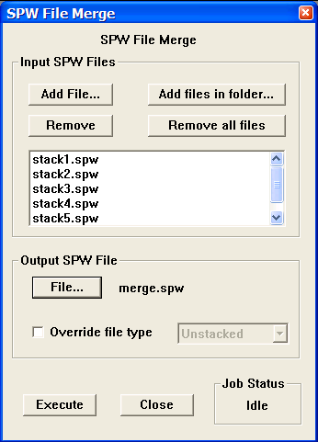
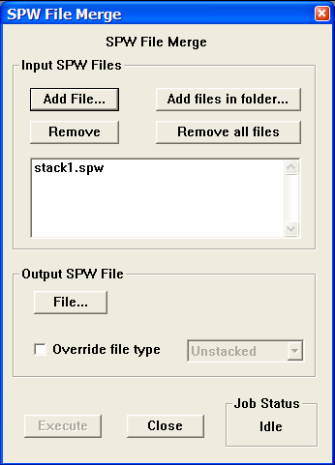
Add the first file… …. and additional files. Use
The File… button in the Output SPW File subwindow to create the output file name.
Click on Execute to generate the output file.

Tape Image Verify

The Tape Image Verify capability allows you to compare files from any combination of attached SCSI tape drives or disk image files. This enables you to verify both media integrity for tape files and byte-level accuracy of image copies made previously. To use the Tape Image Verify utility, simply click on the Tape Image Verify button in the Main Window and the Verify window will appear.
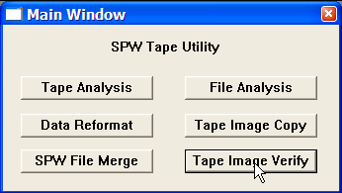
Main Window dialog
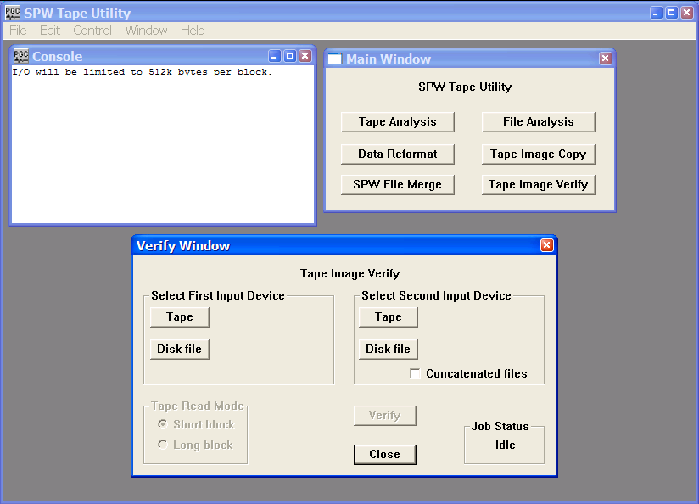
Verify Window dialog

The remainder of the chapter will: (1) discuss the various features of the Verify Window, and (2) provide an example of verifying a SEG-Y tape image.

Verify Window
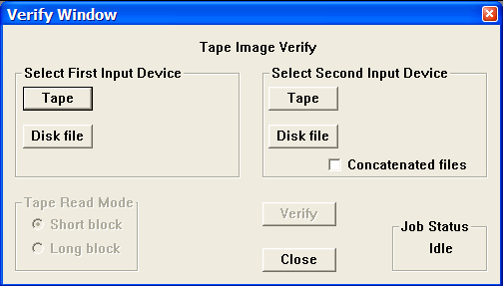
The Verify Window.

Parameter Dialog

Select First Input Device – The Select First Input Device options are used to select the first of two files to be compared.

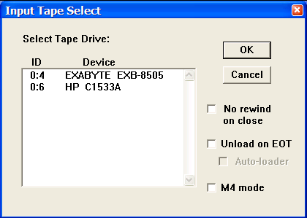
Tape - The Tape button opens the Input Tape Select dialog, which is used to select an attached SCSI tape drive containing a tape with data to be verified.

No rewind on close – The input tape will not be rewound at the end of the tape verify session.

Unload on EOT – Tape automatically unloads when the end of tape marker is found.

Auto-loader – Indicates that an auto-loader will be used to load multiple input tapes.

M4 mode – Check M4 mode if an M4 tape drive is selected.
Disk - The Disk file button opens the Open Disk File dialog, which is used to select a disk file containing data to be verified.
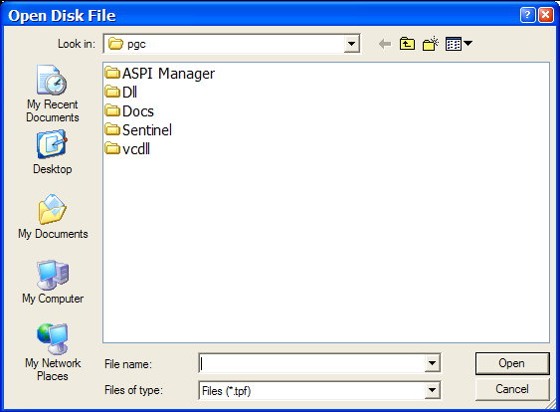

Select Second Input Device – The Select Second Input Device options are used to select the second of two files to be compared.

Tape - The Tape button opens the Input Tape Select dialog, which is used to select an attached SCSI tape drive containing a tape with data to be verified.

No rewind on close – The input tape will not be rewound at the end of the tape verify session.

Unload on EOT – Tape automatically unloads when the end of tape marker is found.

Auto-loader – Indicates that an auto-loader will be used to load multiple input tapes.

M4 mode – Check M4 mode if an M4 tape drive is selected.
Disk - The Disk file button opens the Open Disk File dialog, which is used to select a disk file containing data to be verified.

Concatenated files – If checked, indicates that the file on the second input device were created by concatenating the original input files. ,

Tape Read Mode – The Tape Read Mode options do not apply to the Windows version of IO Utility.

Short Block – To be used if the SCSI device reads in data blocks less than or equal to 64kb. This is the case with Mac OS X.

Long Block – To be used if the SCSI device reads in data blocks larger than 64kb. This is only an issue on the older Mac OS (pre OS X).

Example: Verifying a SEGY Tape Image

Step 1: Select the first and second input devices containing. The second device will contain a tape image of the contents on the first device. In this case, the tape in the second device contains an image of the SEGY files on tape in the first device.

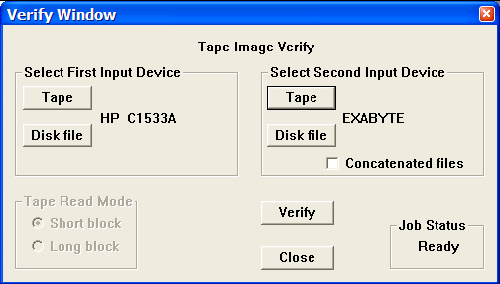
Two tape drives are selected, the second of which contains an image of the SEGY files on the first.

Step 2: Click on Verify. As the verify job progresses, a block will be read from each of the two inputs and the contents of the blocks will be compared byte for byte. If at any point during the comparison of data blocks and EOFs there is an inconsistency between the two inputs, the job will fail and an error message with appropriate information will be displayed in the console window.
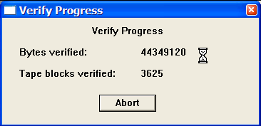
As the verification proceeds, a dialog will report the progress in terms of bytes and blocks verified.

Step 3: If the verification procedure was successful, a message to that effect will be displayed in the Console window.

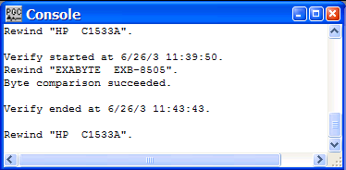
Successful verification.

